PROJECT-1

DEPLOYING A WEBSITE ON AWS EC2 INSTANCE

Virtual private cloud:

Steps :

1. In AWS console, search VPC.

2. In VPC dashboard , you will get my VPC’s and click on myvpc’s.

3. Click on create VPC. Select resource to create as vpc only.

4. Give name as amrutha-vpc and IPv4 CIDR as 10.0.0.0/16.

5. Then click on create VPC

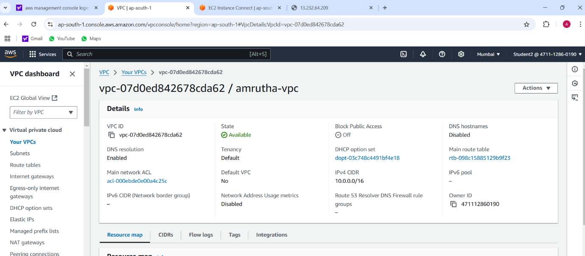

Internet Gateway:

Steps :

1. In VPC dashboard, click on Internet Gateway.

2. To create Internet gateway, click on create Internet Gateway.

3. Then give name as Amrutha-igw and click on create Internet Gateway.

4. Your internet Gateway is created.

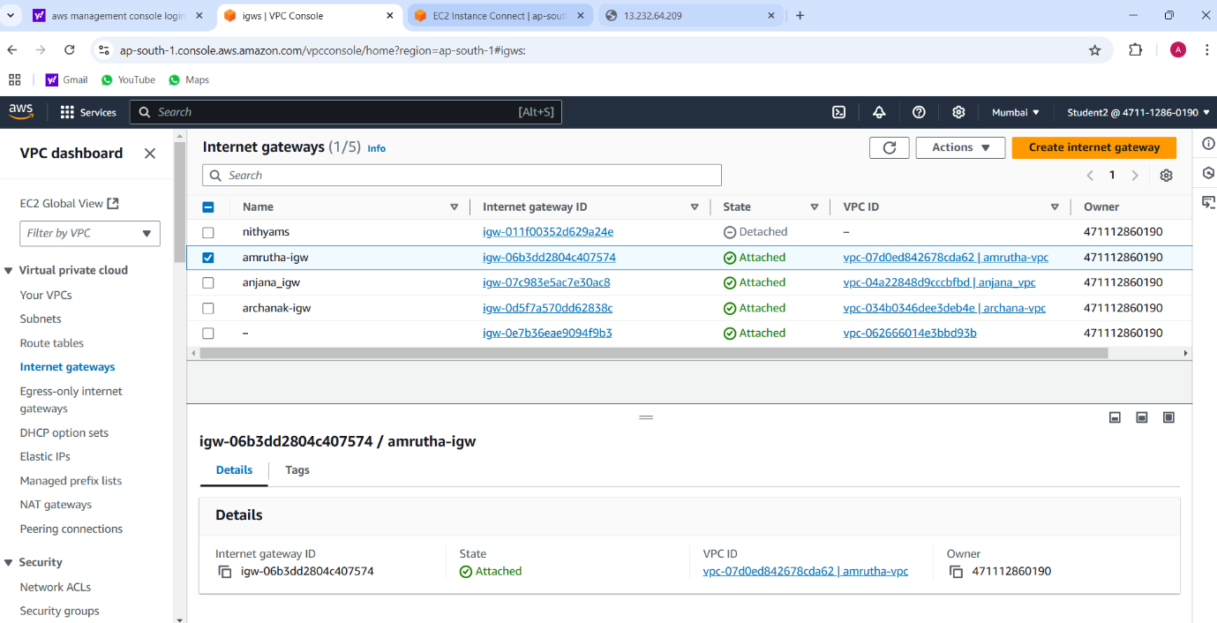

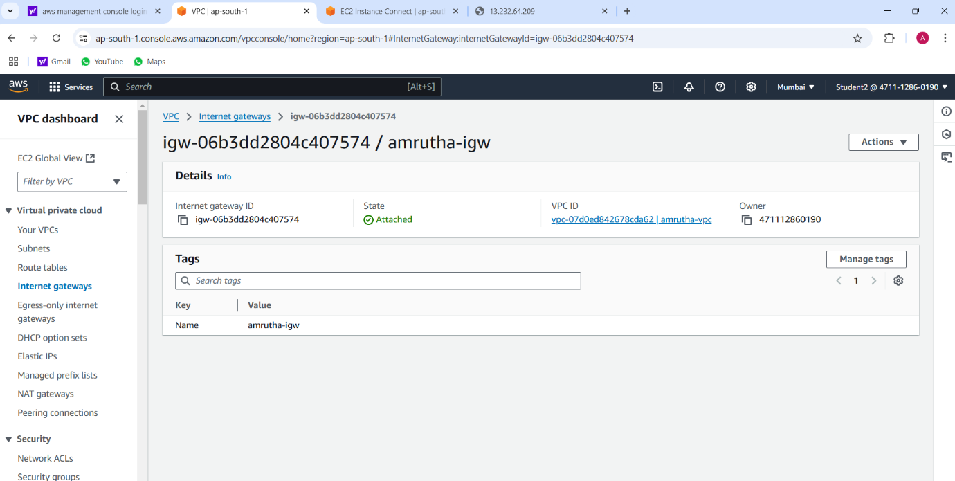

Subnet1:

Steps :

1. To create subnet, go to VPC dashboard under virtual private cloud, click on subnet.

2. Select the vpc you have already created and in subnet setting, give subnet name as public-subnet-01 .

3. Then choose availability zone as region you have selected before creating the vpc and IPv4 subnet CIDR block as 10.0.1.0/24.

4. Then create one more subnet as following subnet but give name as publicsubnet-02 and then choose availability zone and IPv4 subnet CIDR block as 10.0.2.0/24

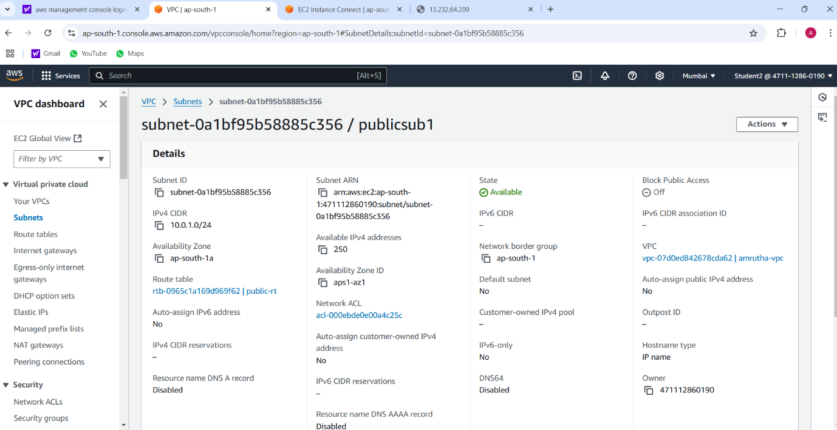

Subnet2:

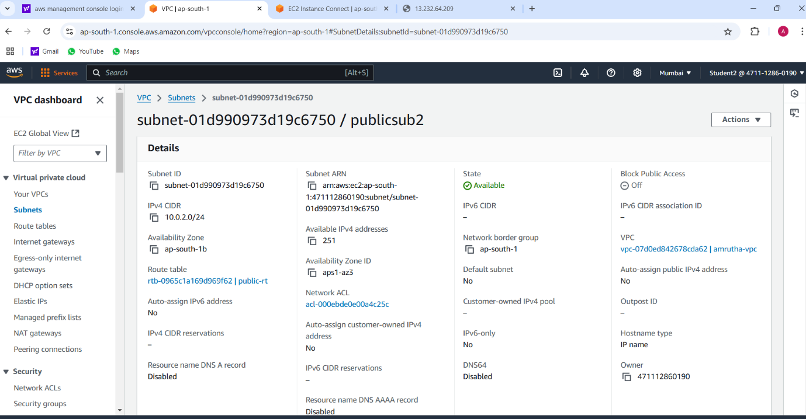

Router Table:

Steps :

1. To create Route table, click on create route table.

2. In route table setting, give route table name as anu-route-table-01 and select vpc that is created.

3. Then click on create route table.

4. After route table is created, go to routes and click on edit route and then click on add route.

5. Then in destination, select 0.0.0.0/0 as destination and target as Internet Gateways .

6. After selecting internet gateway, it allows to select the igw- and select the internet gateway that is created by you.

7. At last click on save changes.

8. Then go to subnet association and click on edit subnet association.

9. Select the subnet you have created and click on save changes.

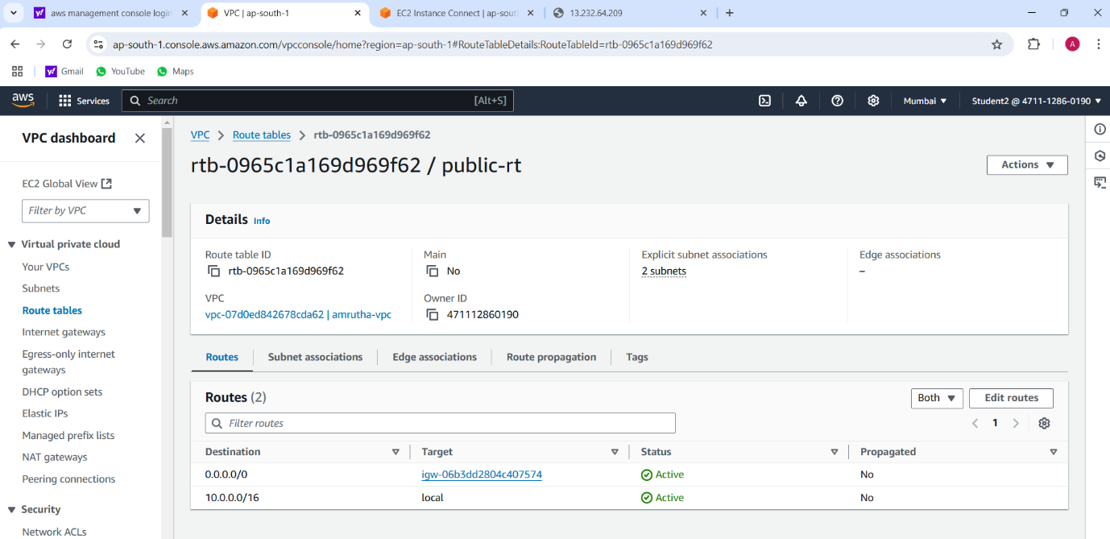

EC2 instance

Steps:

1. Go to EC2 in AWS console and click on instances.

2. Click on launch instance and give the name for the instances as Amrutha server.

3. After giving name to instances, select application and OS Images as Amazon Linux and instances type as t2.micro .

4. In keypair, click on create keypair and give keypair name as amrutha-keypair and click on create keypair. The keypair is created.

5. Then in network setting, click edit. Select vpc and subnet and also assign public IP as enable.

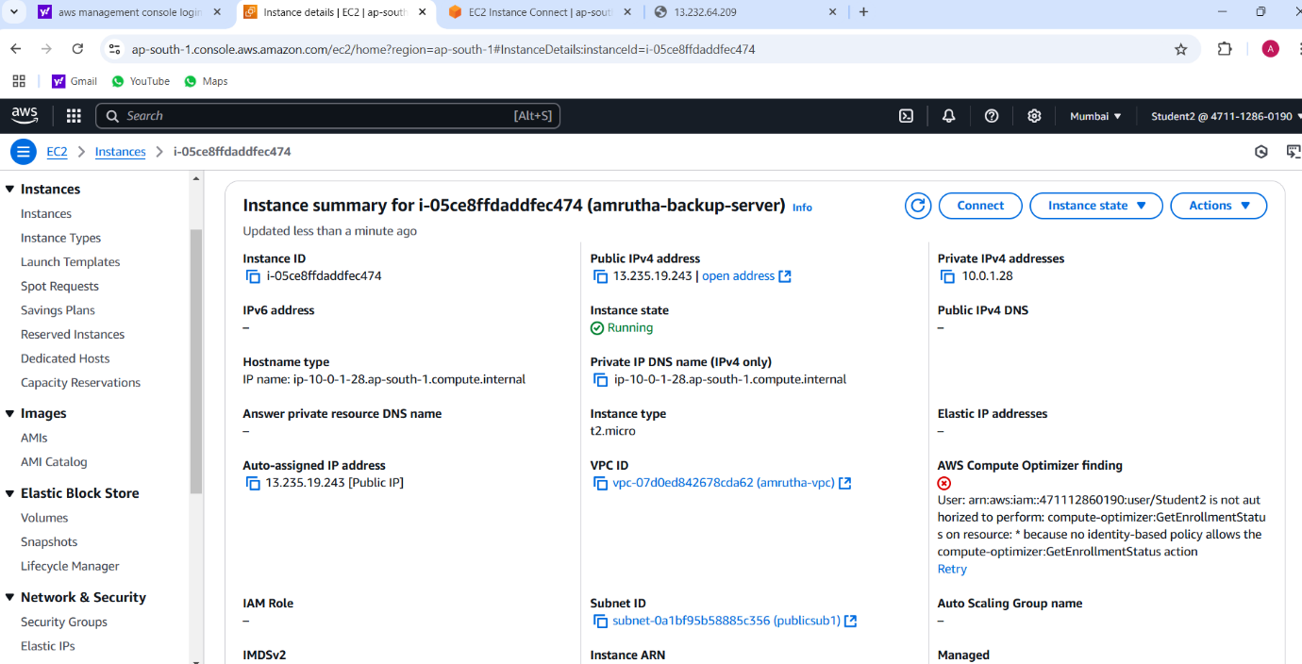

Connection

Steps:

1. Select the instance you have created and click on connect.
2. Go to SSH client. Copy the example.

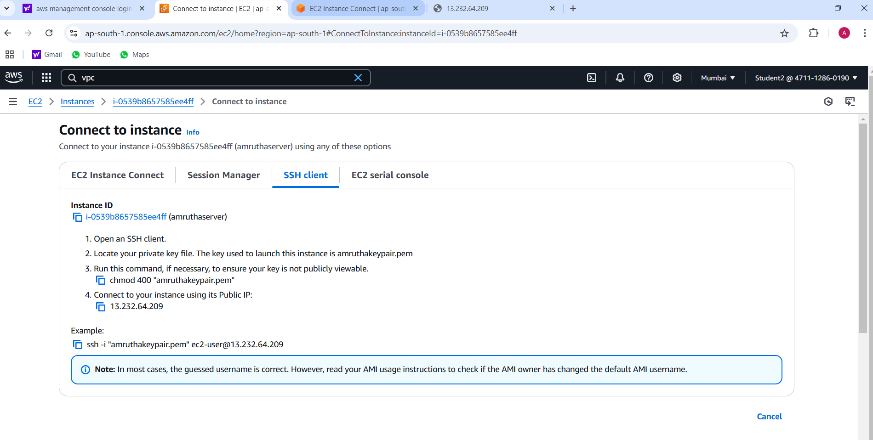

Command prompt:

Steps:

1. Go to command prompt and follow the following the commands:

* Cd Downloads
* Paste the SSH client example.
* Yow will get to confirm the connecting, type yes.
* Then type sudo su and cd.
* Then type yum install httpd -y.
* After installation, type cd /var/www/html.
* Then type vi index.html and vi editor will get opened and press i to insert the content.
* After that, press esc and :wq to save the content.
* Go to instances, copy the public ip and paste on browser url.

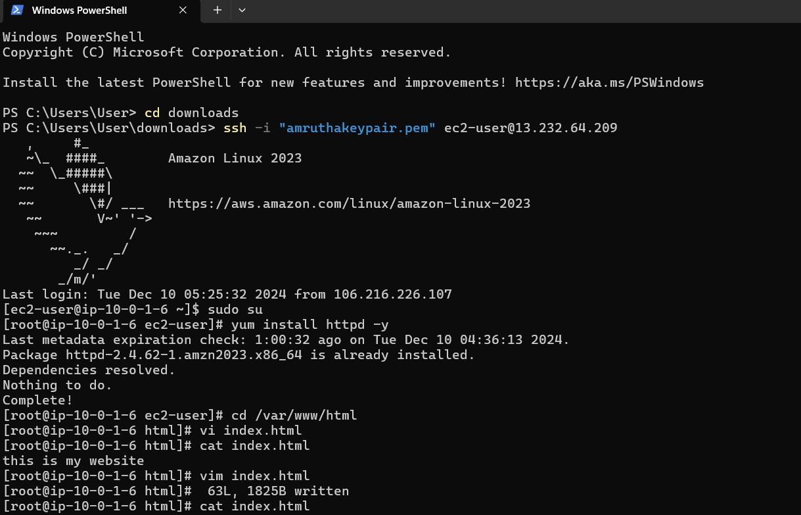

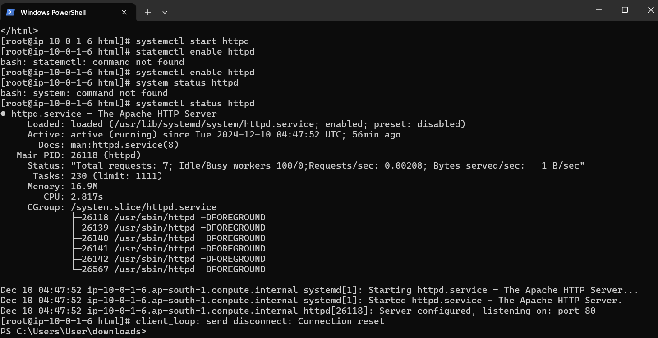

Final Result**:**

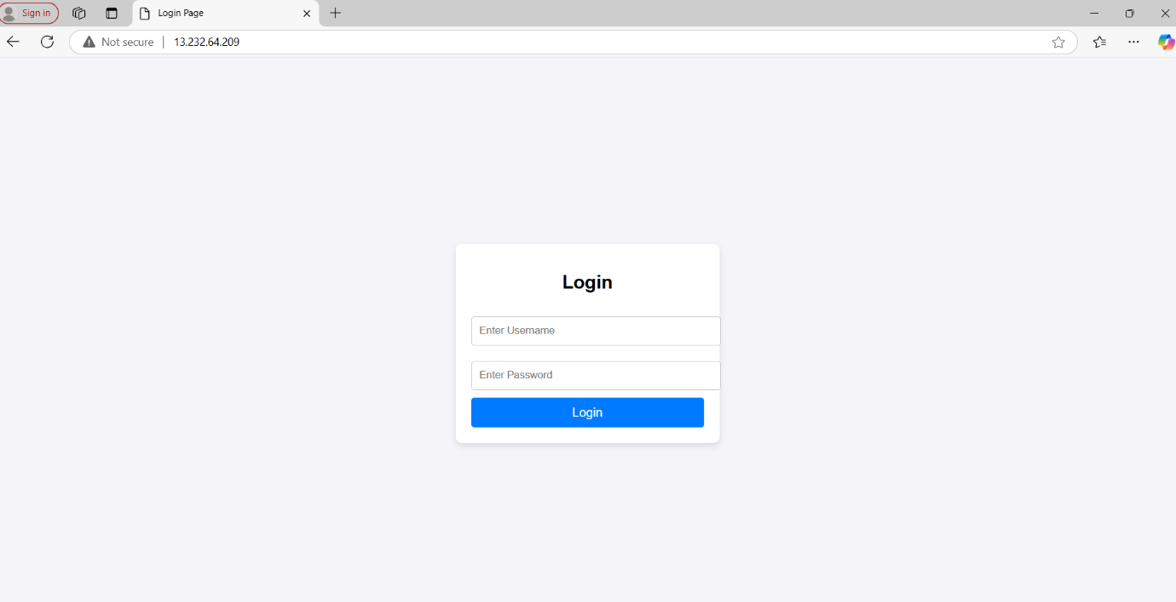

**PROJECT-2:**

**HOW TO CREATE NEW INSTANCE USING AMAZON MACHINE IMAGE**

Creating image:

Steps:

1. To create image using AMI, go to EC2 and click on instances.
2. Select the instance that is created before and click on action.
3. In action, select image and template. In image and template, select create images.

Give name as amrutha-server-backup and description to the instances

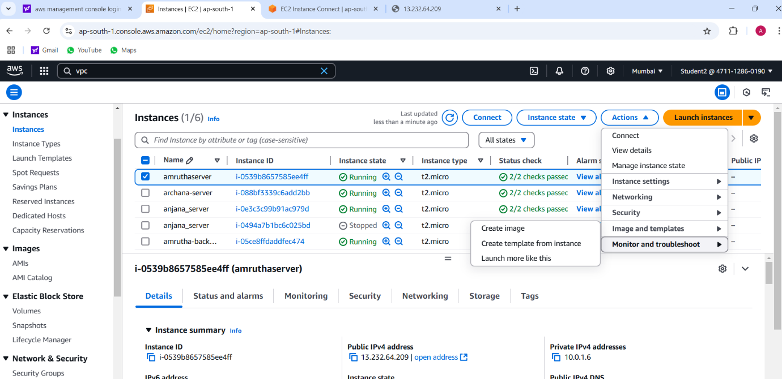

**AMI Summary:**

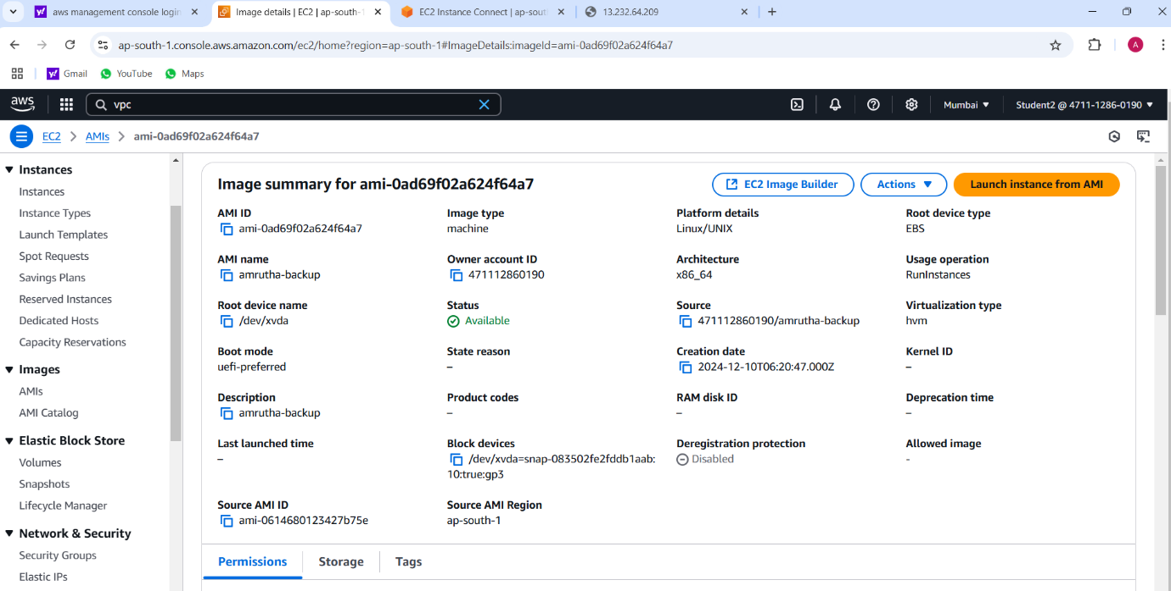

After Launching the backup server:

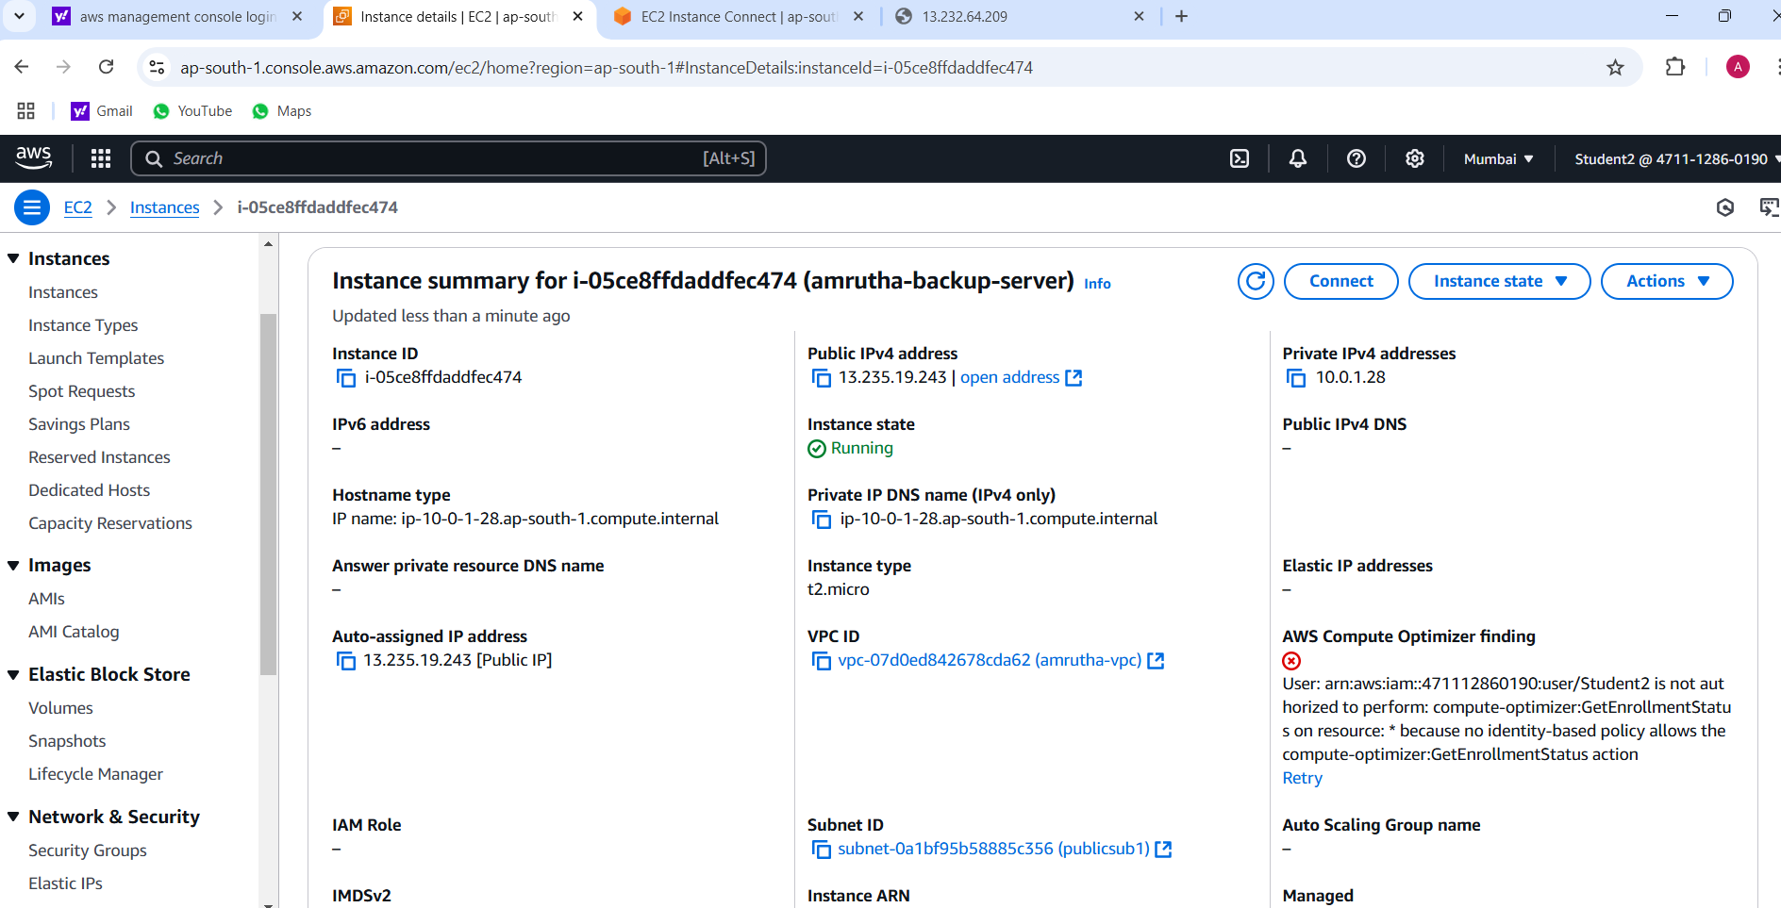

Final Result:

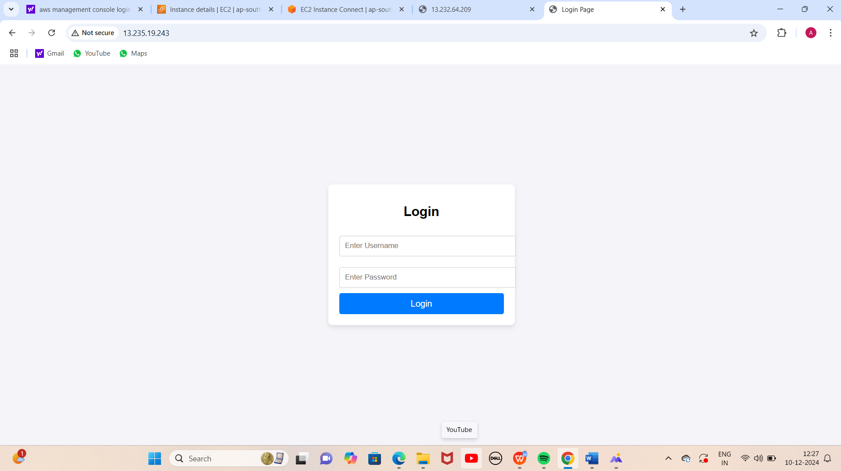

**PROJECT-3**

**how to connect private server through the internet using natgateway (jump server/bastion host)**

Virtual private cloud



Internet Gateway :



Public subnet 1



Public subnet 2:



Private route table:

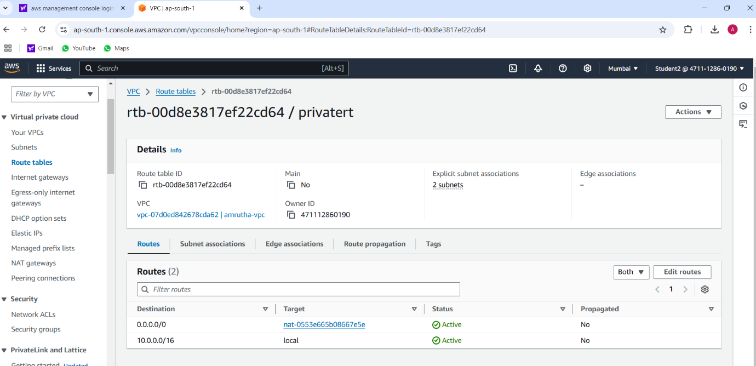

NAT Gateway :

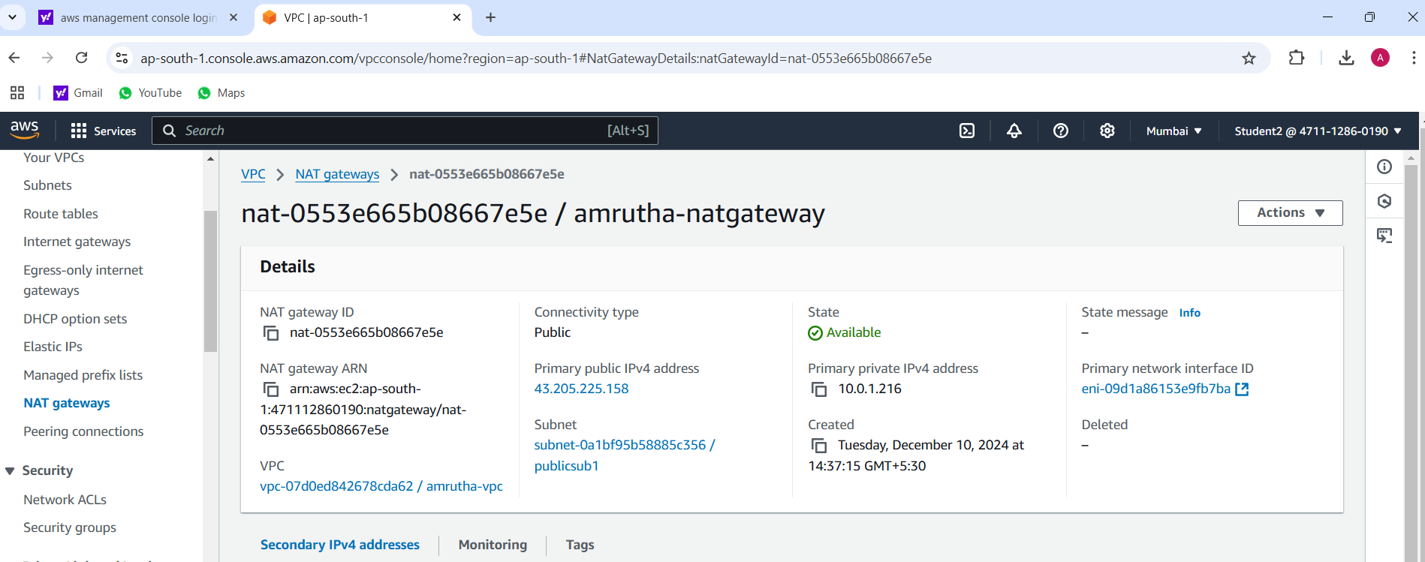

Instances:

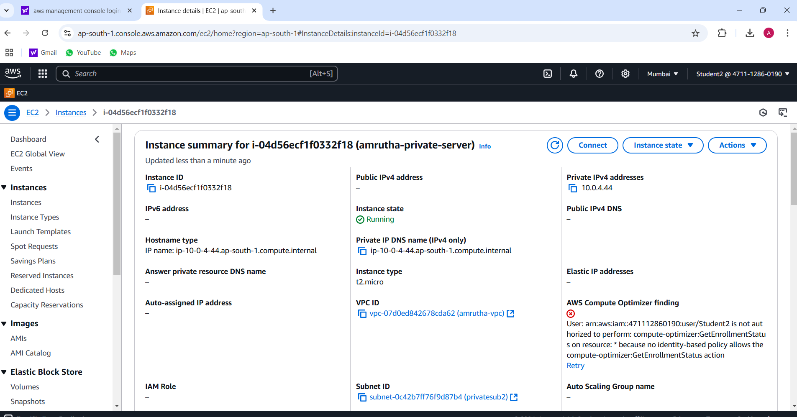

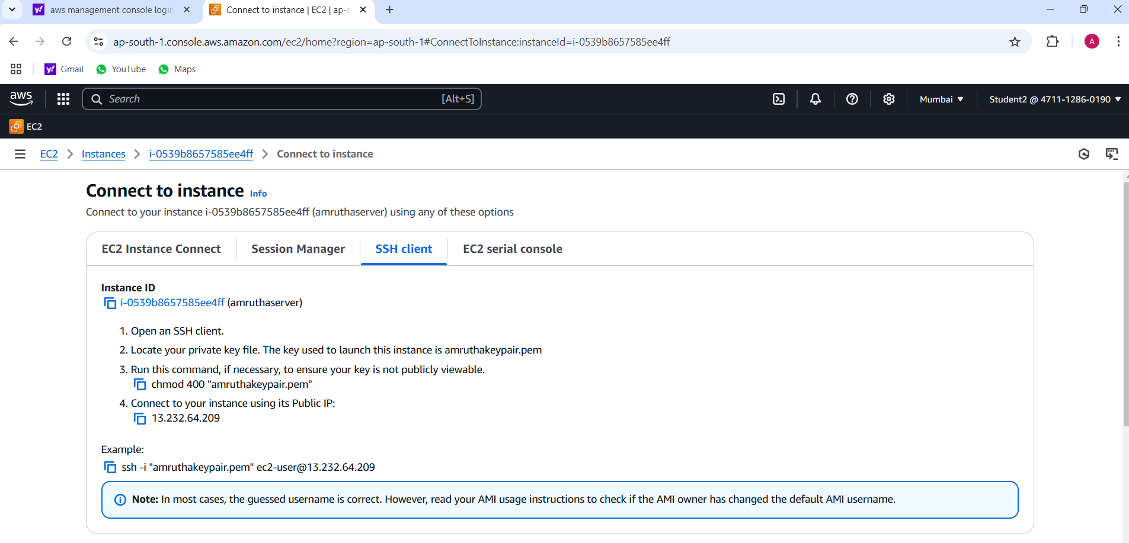

**Final result:**

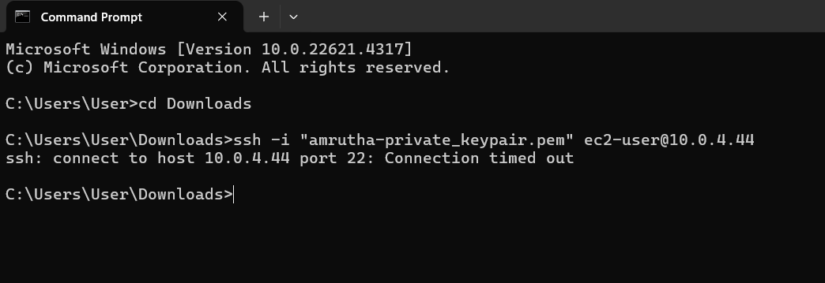

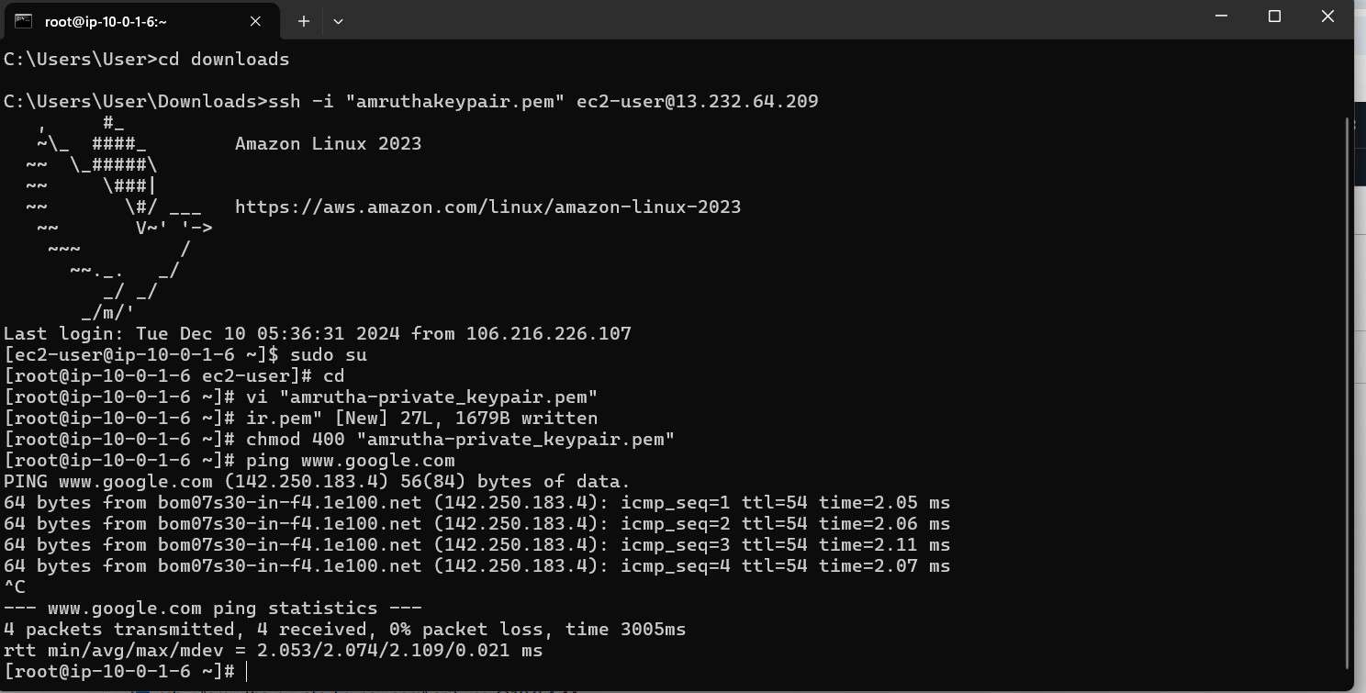

**Project-4**

**Hosting a static web site using S3 bucket**

S3 bucket

Steps:

1. Go to search bar and type s3. Click on s3.
2. In S3 dashboard, go to general purpose buckets and click on create bucket button.
3. In general configuration, select bucket type as general purpose and give name as amrutha2002.

Click on create bucket button. Your bucket is created.

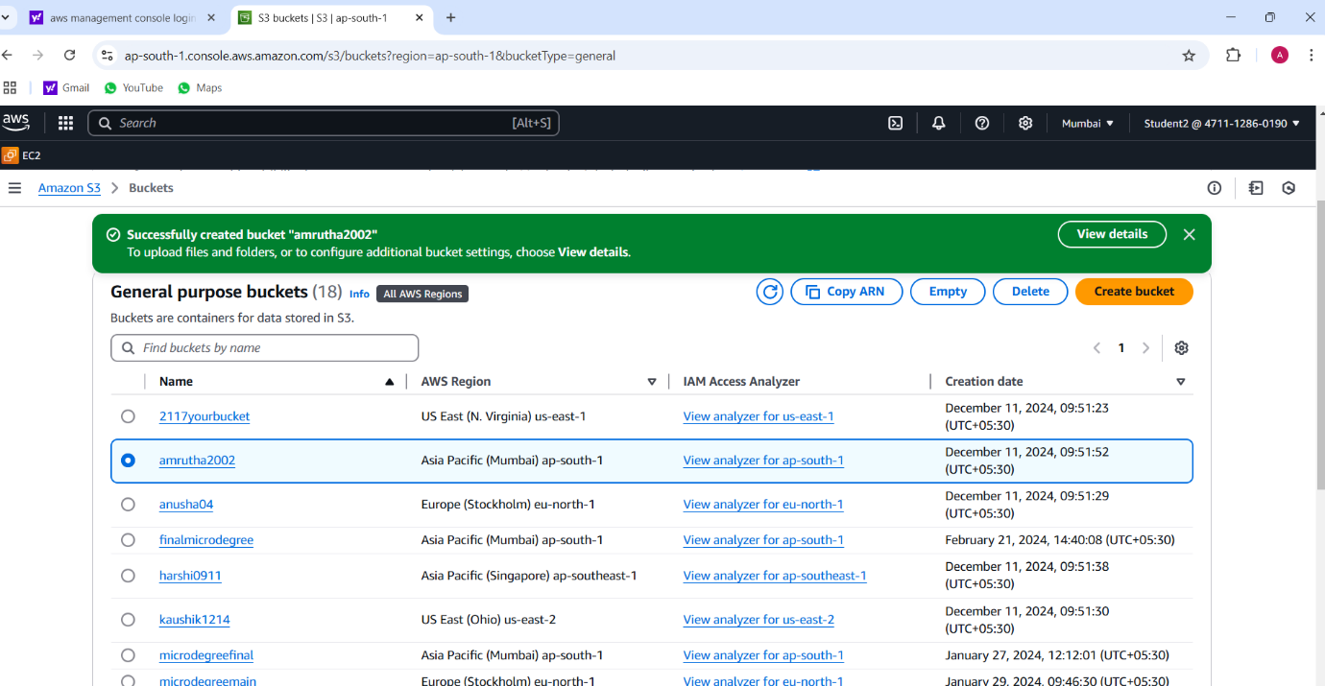

Uploading a file:

Steps:

1. Click on created bucket.
2. Bucket window gets opened and click on upload button.
3. In upload window, select files and folders and Click on add files and select the file you want to add.
4. Then click on upload. Your file is uploaded.

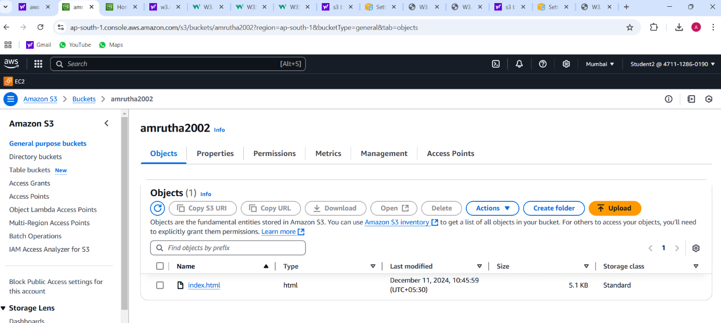

Static website hosting:

Steps:

1. Select the properties, go to static website hosting and click on edit.
2. Give index document name as file name that is dailyping.html and click on save changes button.

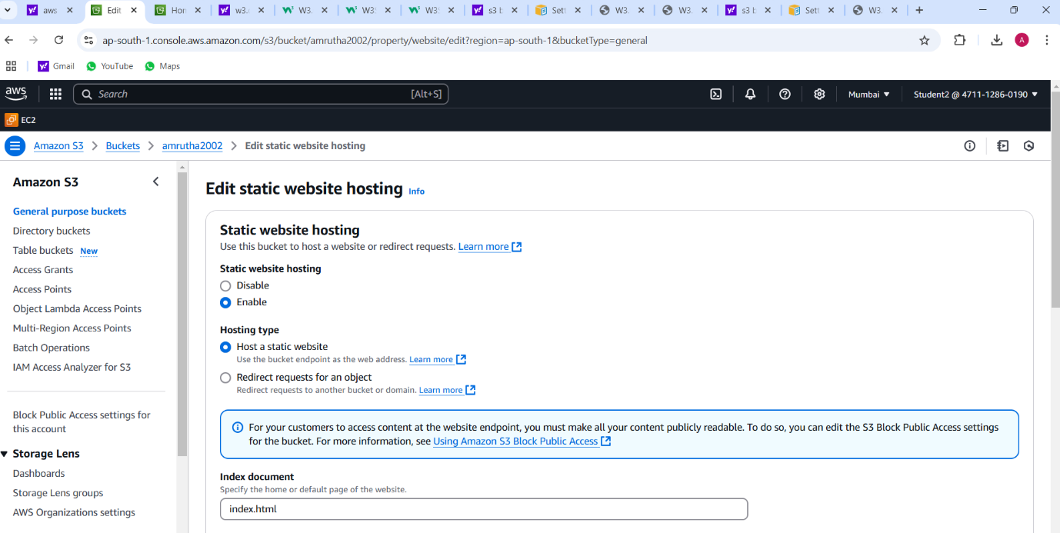

Bucket setting:

Steps:

1. Go to permission, select block public access and click on edit.
2. Under block public access (bucket setting), uncheck the block all public access and click on save changes button.

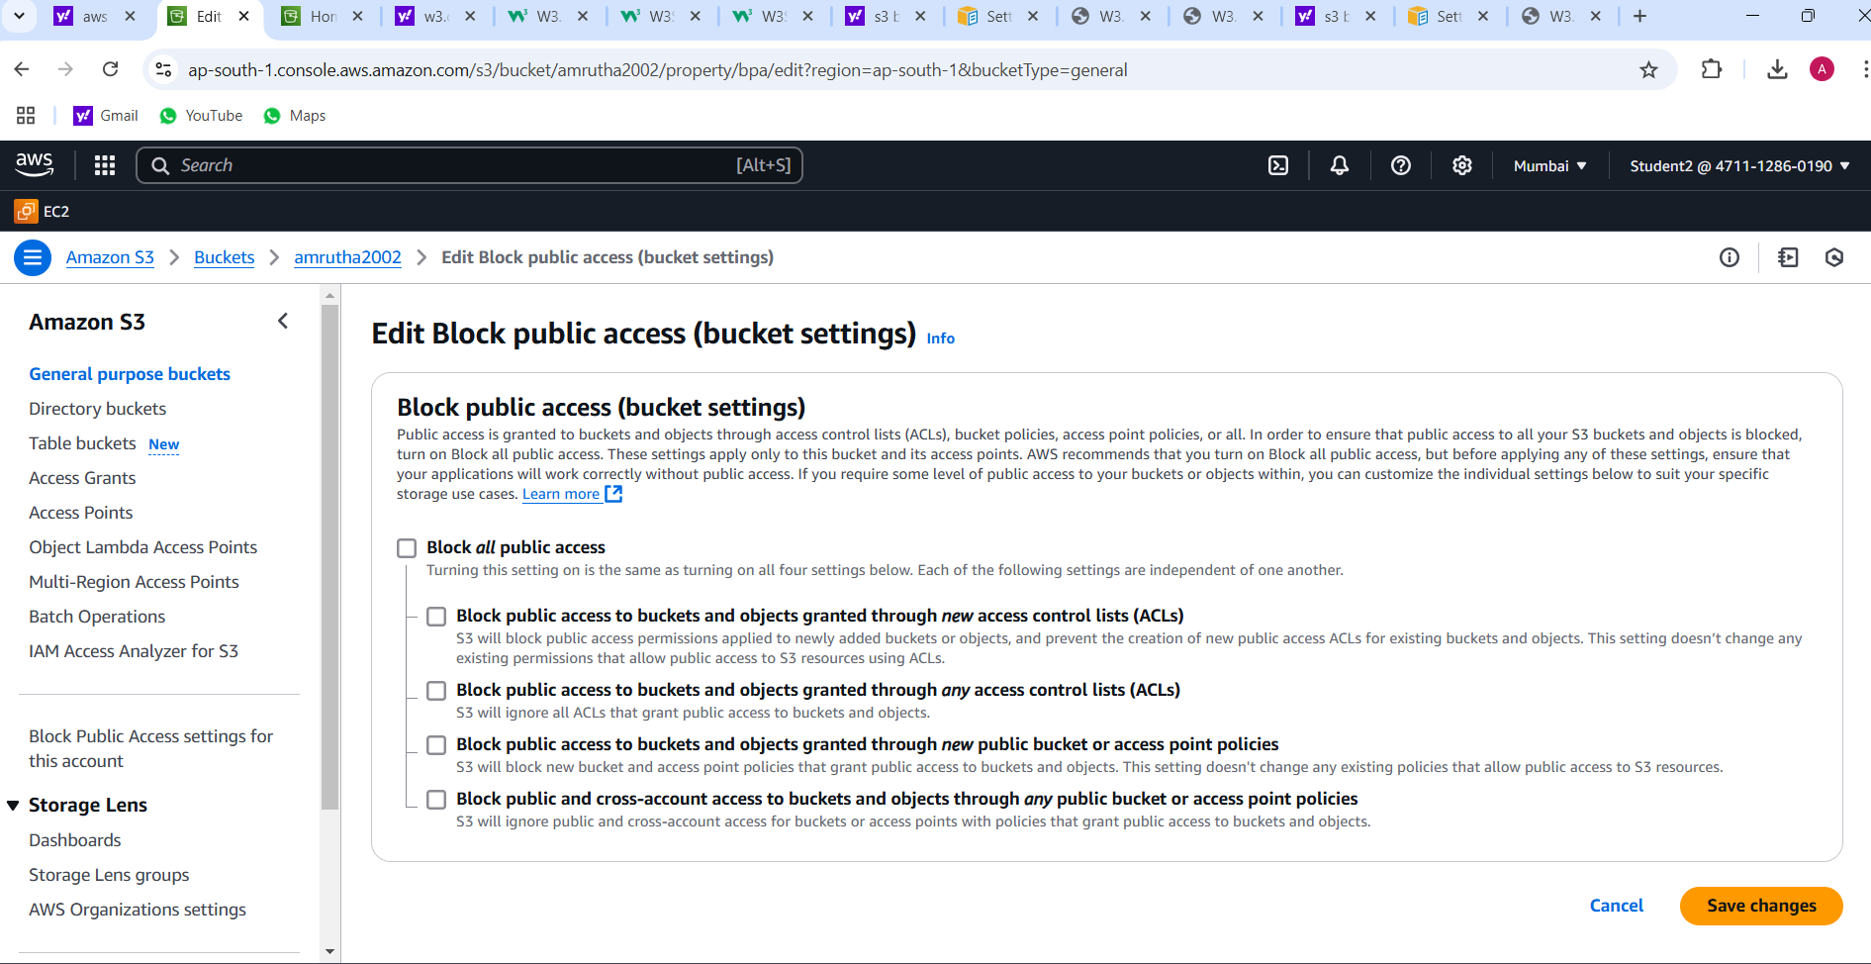

Setting permission for website access and add bucket policy:

Steps:

1. Go to google browser and type bucket policy for static website.
2. You will get setting permission for website access and click on it.
3. You will get add a bucket policy and copy the code from the editor.

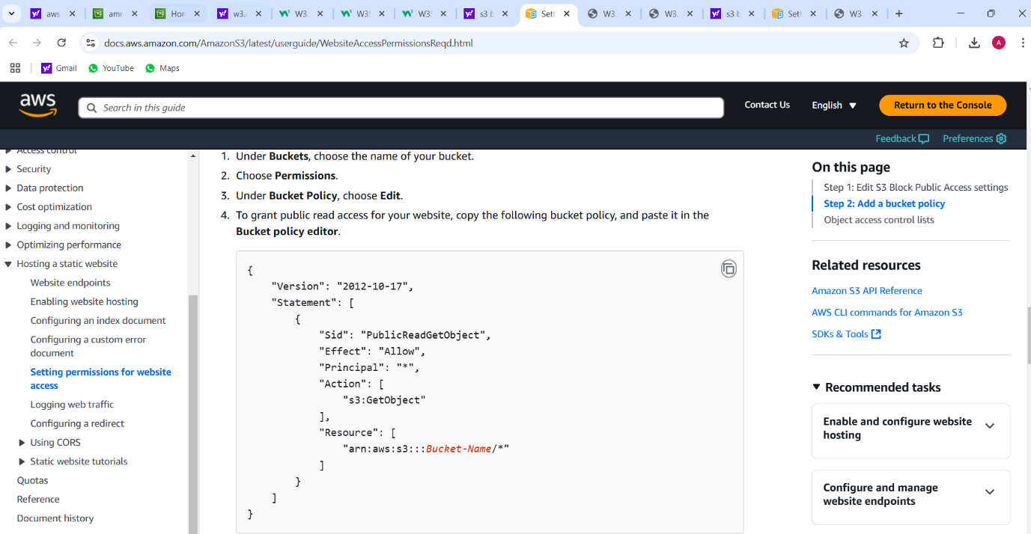

Bucket policy:

Steps:

1. In permission, select bucket policy and click on edit.
2. Paste the code copied from the editor and change the ‘Bucket-Name’ as amrutha2002 (created bucket name).

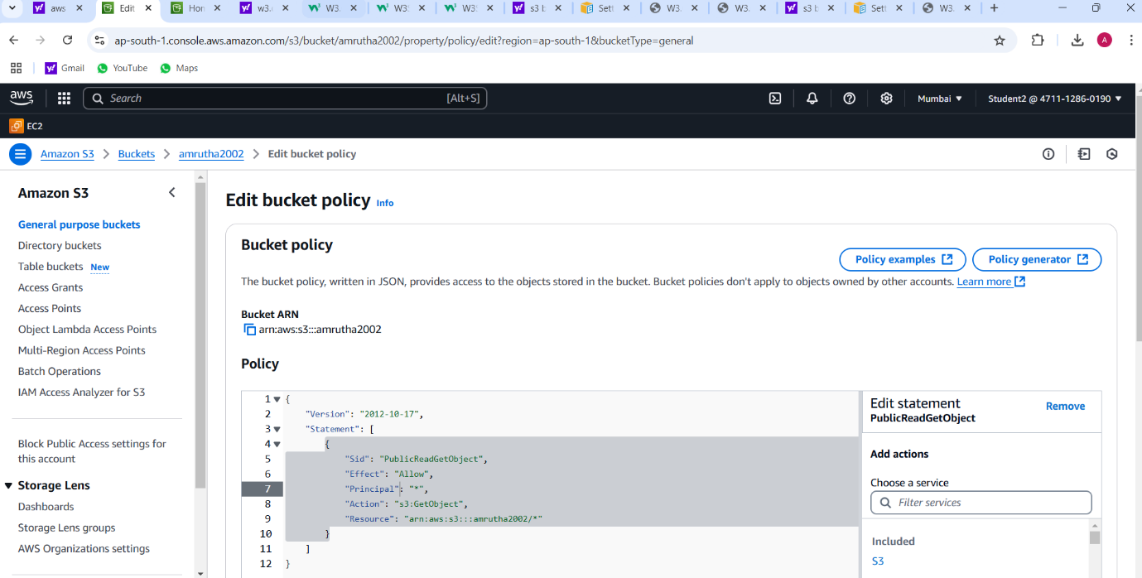

Static website hosting url:

Steps:

1. In properties, under static website hosting, copy the bucket website endpoint url and paste it on google browser.

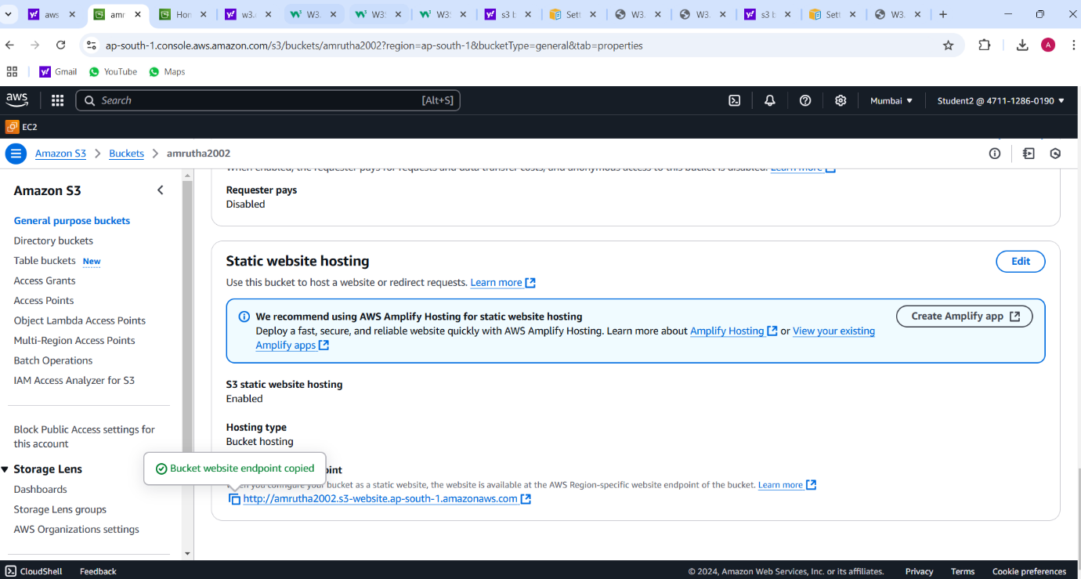

**Final result:**

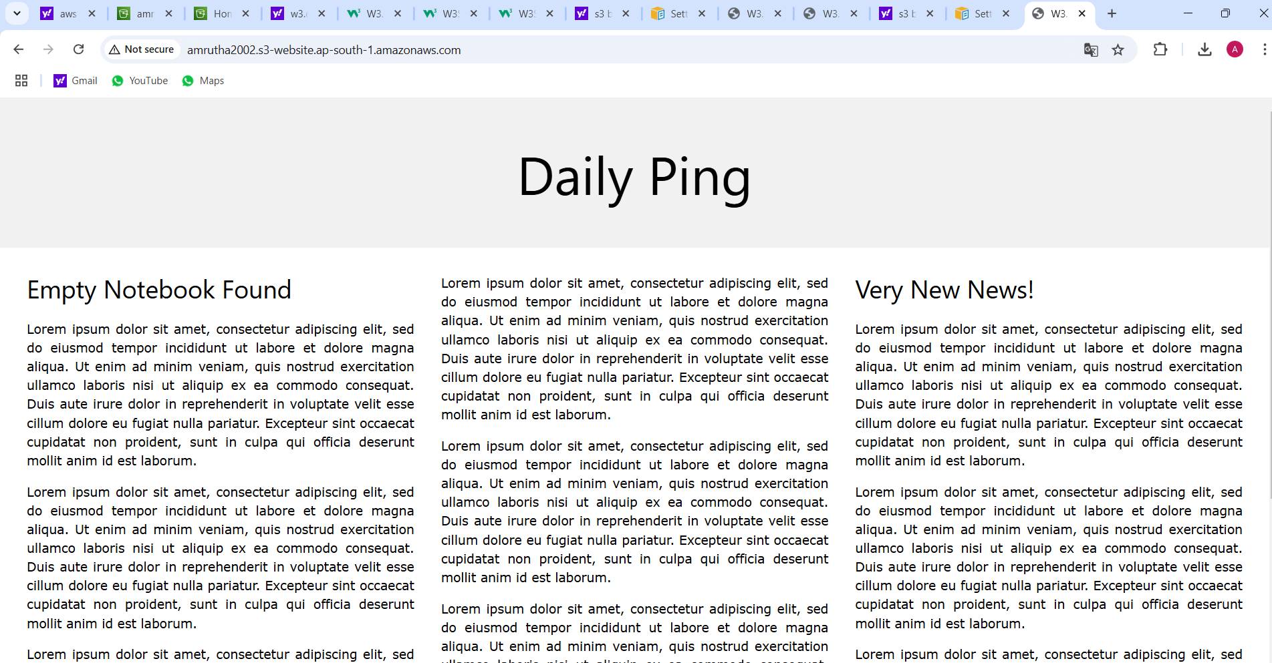

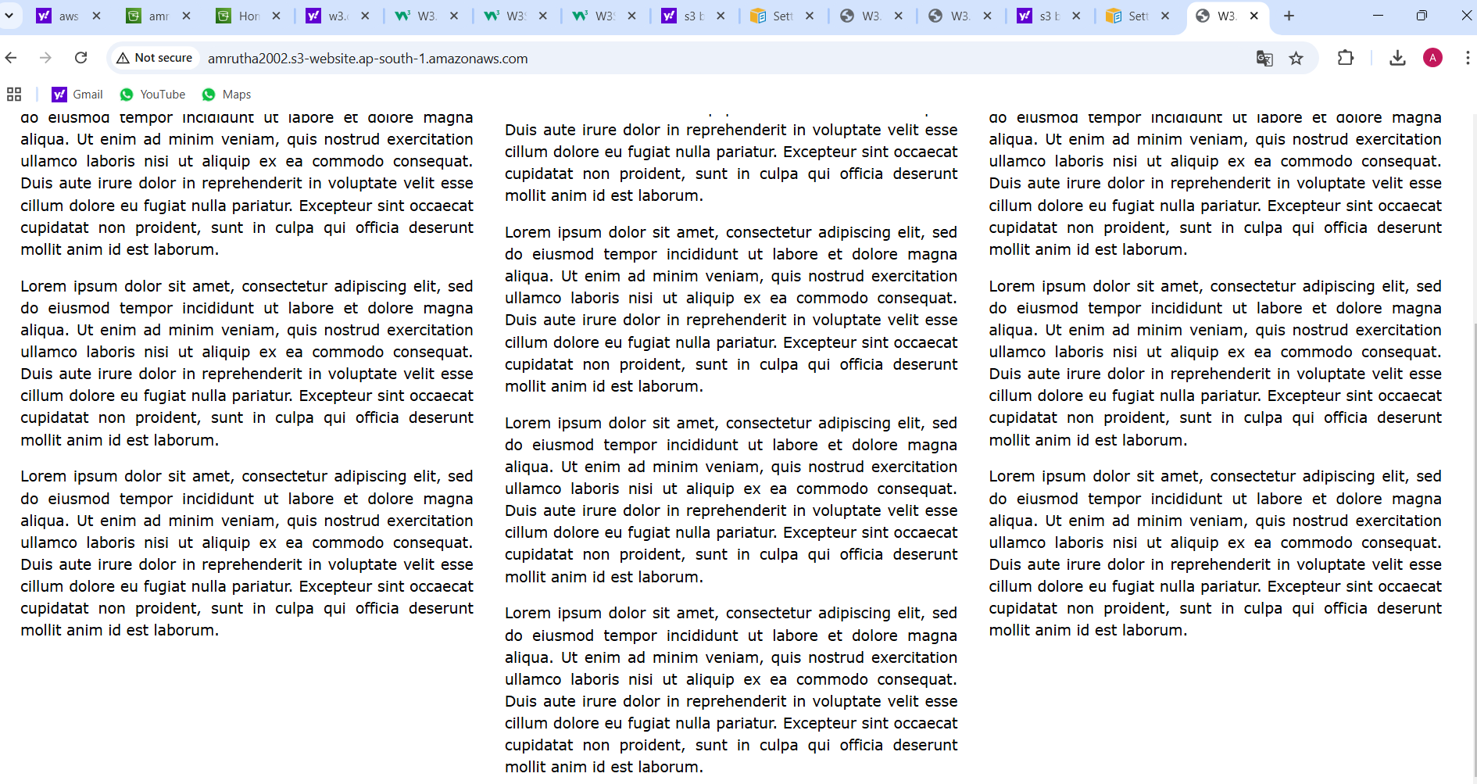

**PROJECT-5**

**Launching the website using Load Balancer DNS name**

VPC:



Internet gateway:



Subnets1:



Subnet2

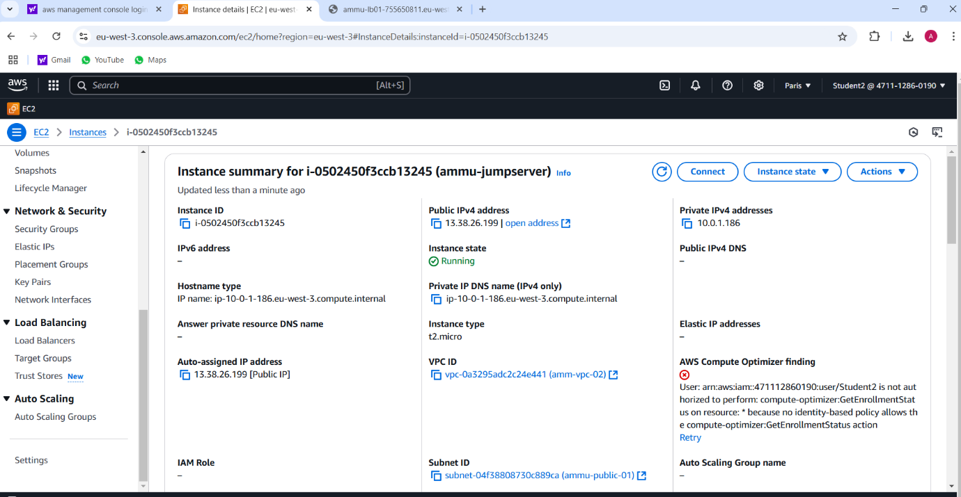

Route table:



Natgateway:



Instance:

Instance:

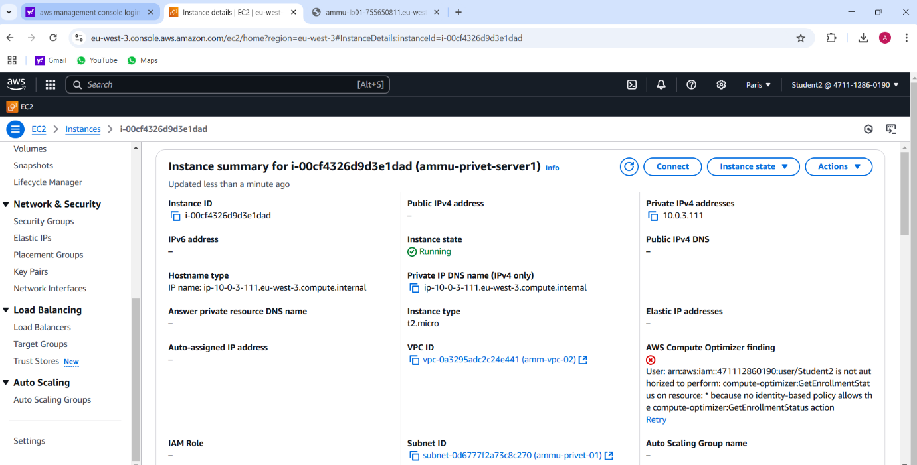

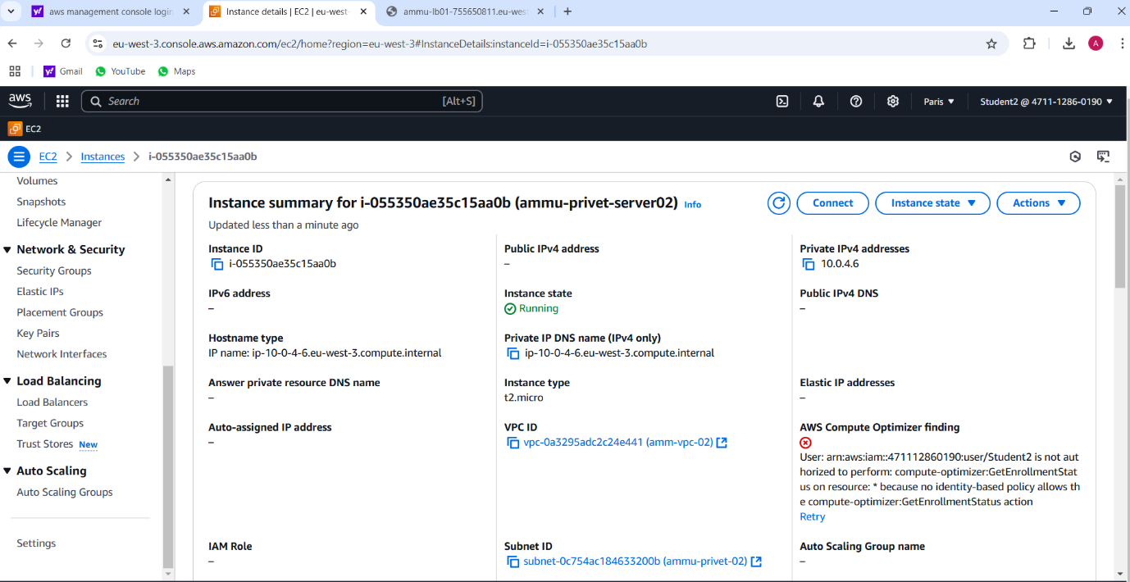

**Target group:**

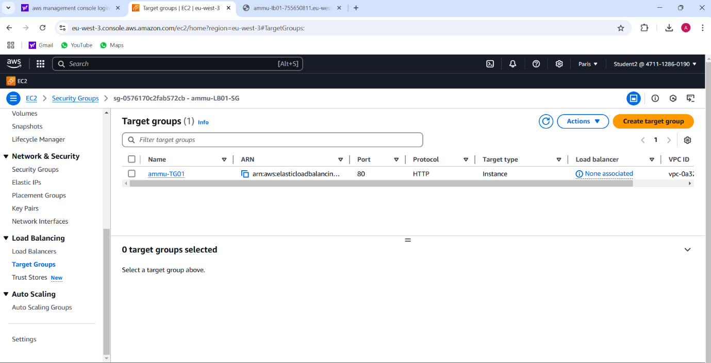

**Load Balancer:**

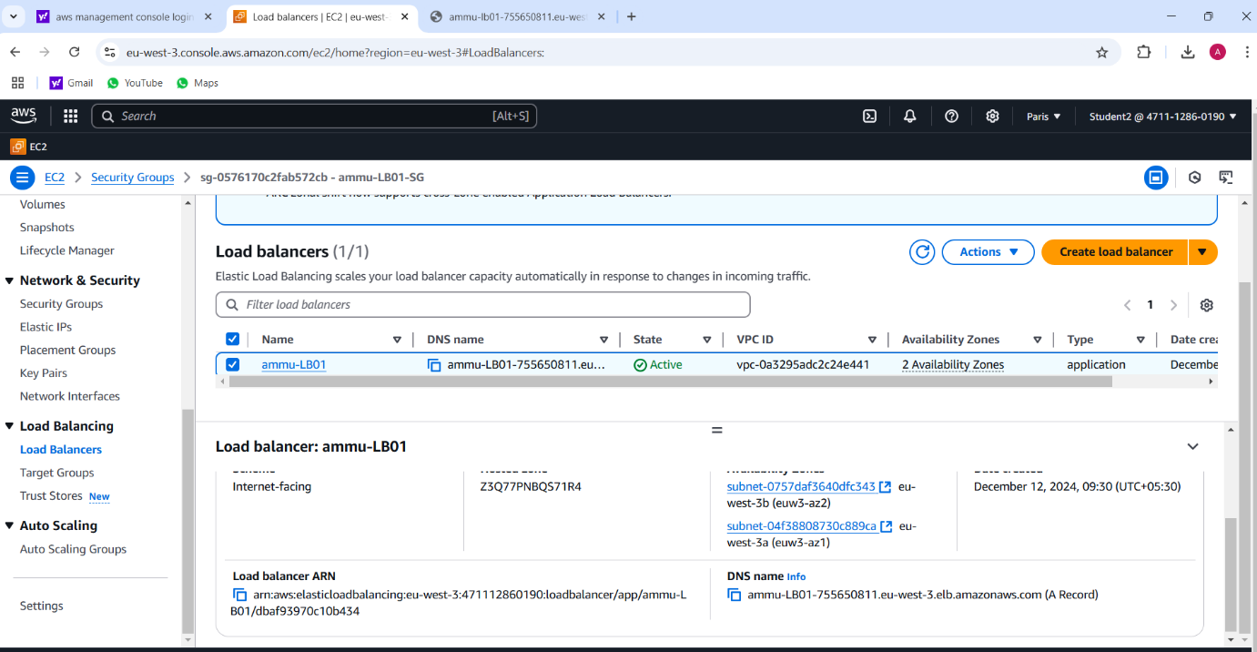

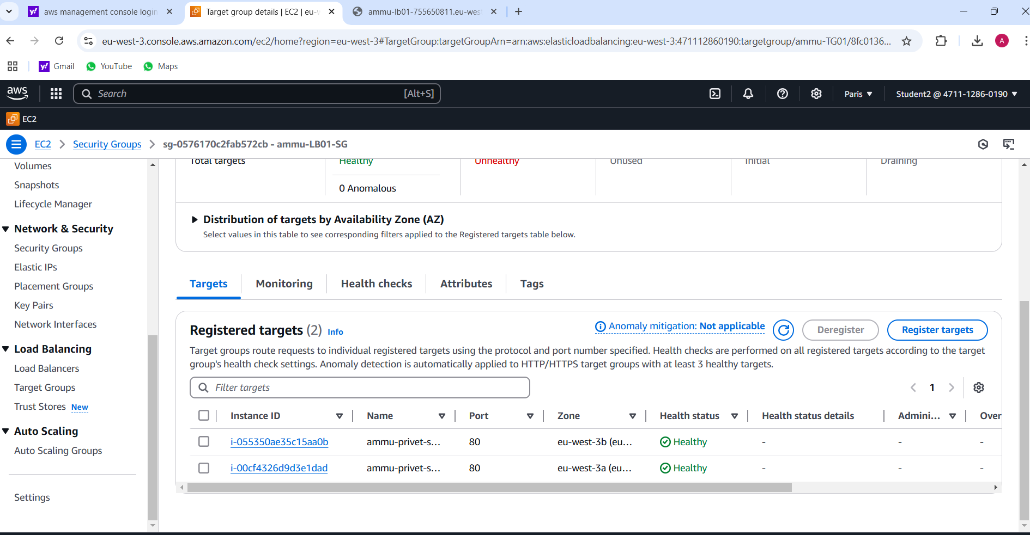

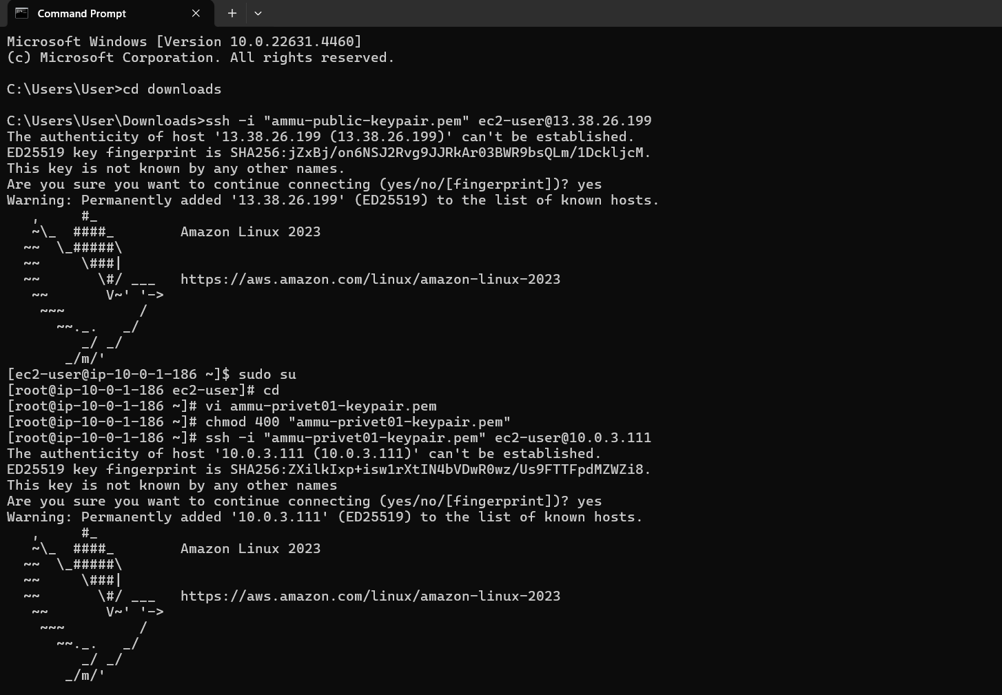

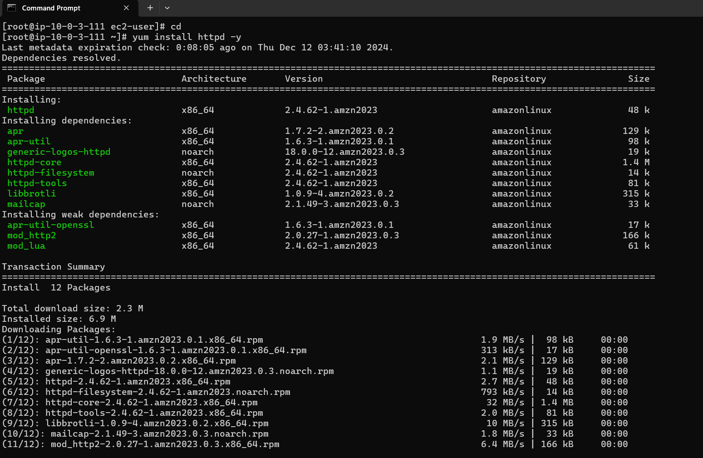

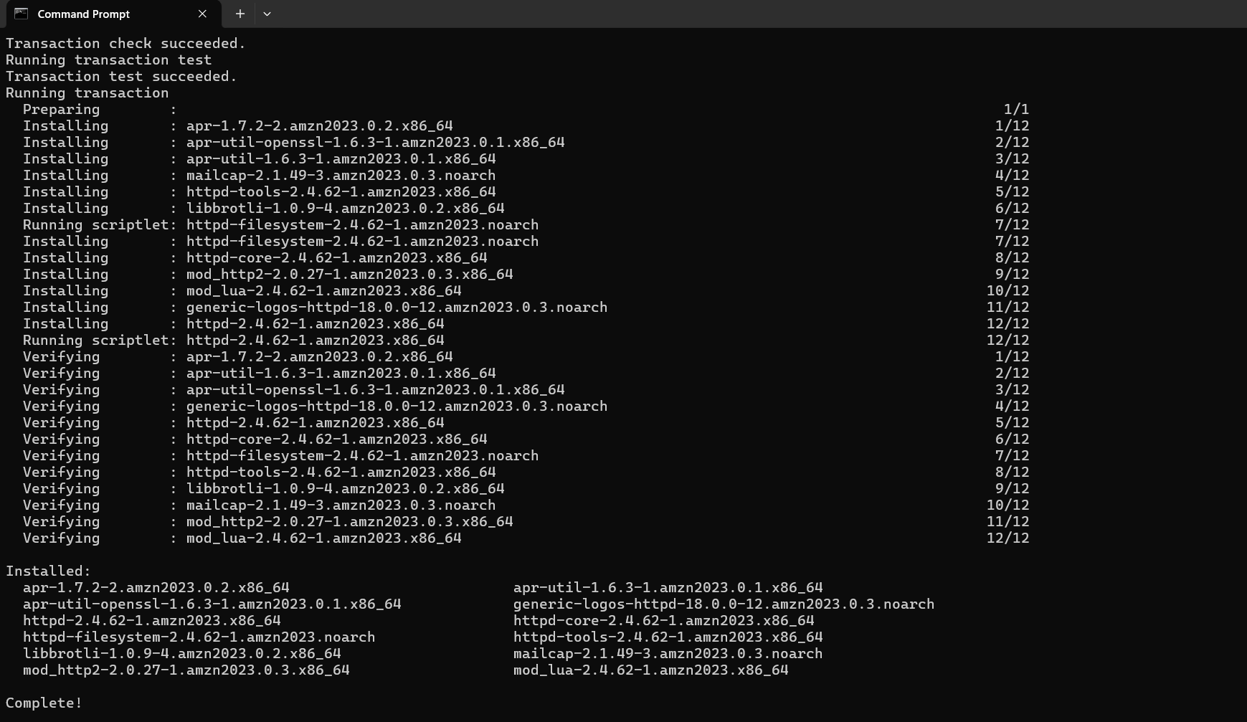

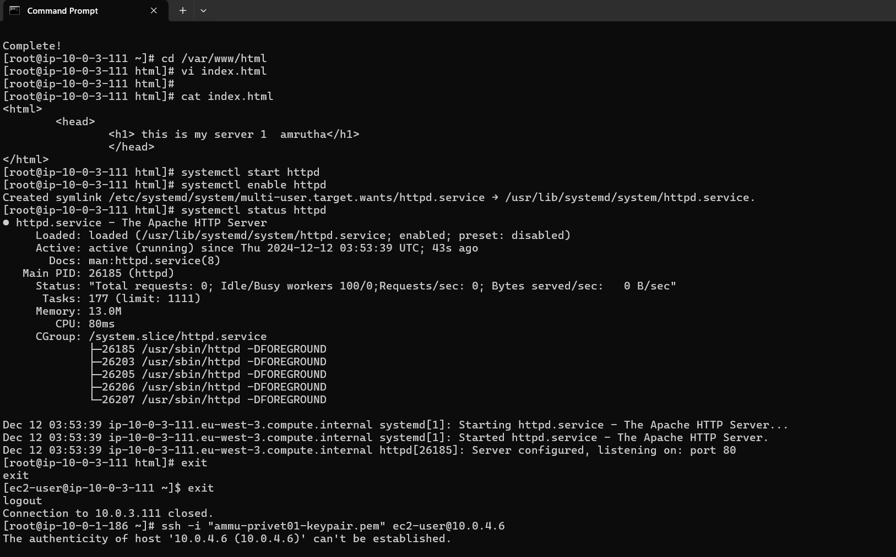

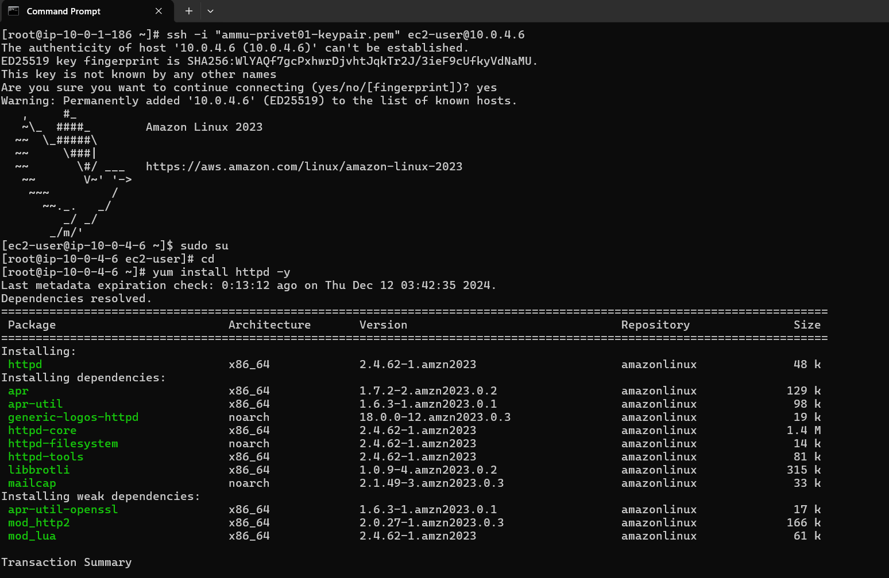

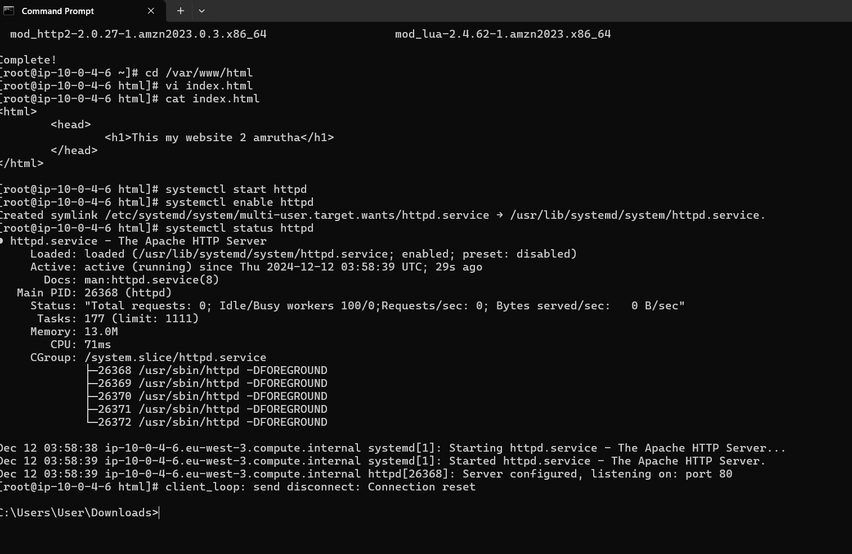

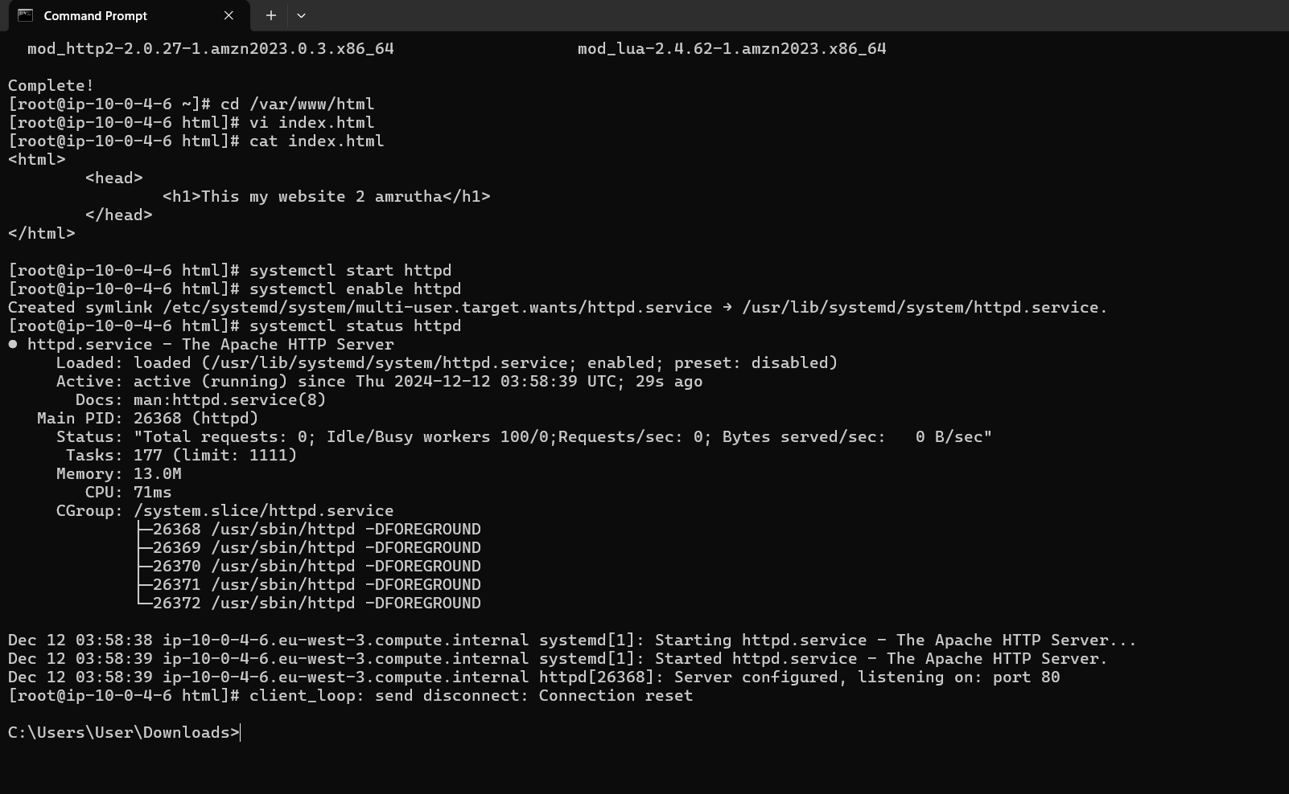

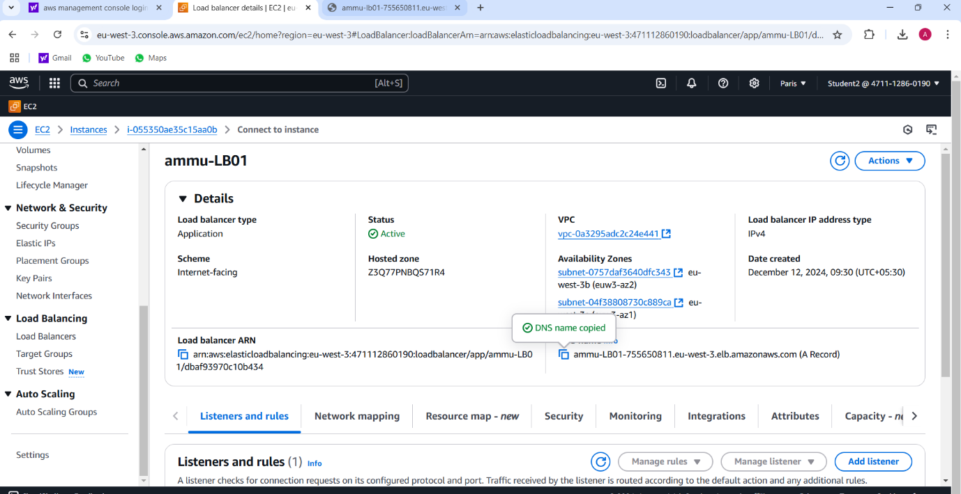

**Final result**

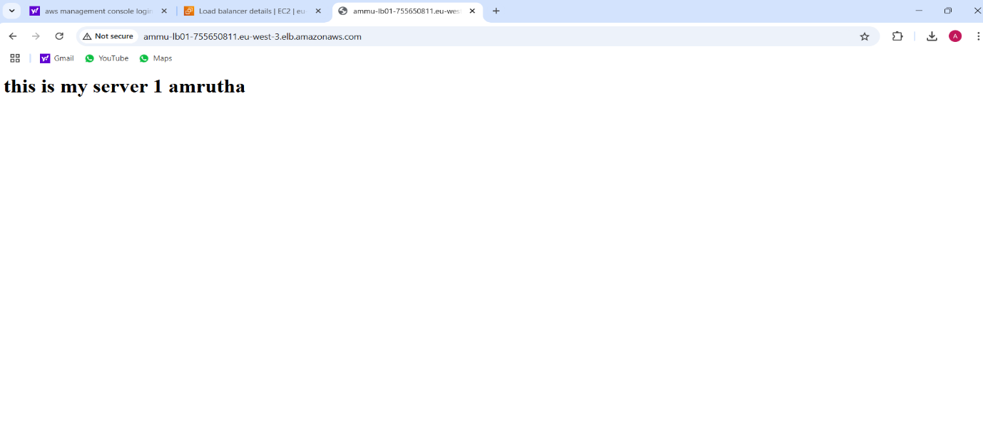

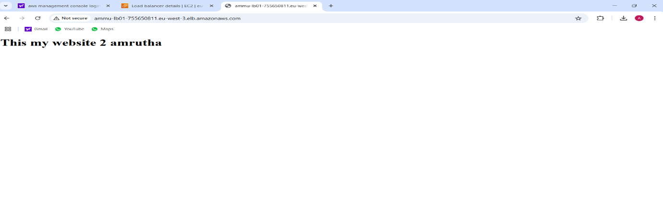

**6.PROJECT**

**HOW TO CREATE REPOSITORY IN GITHUB**

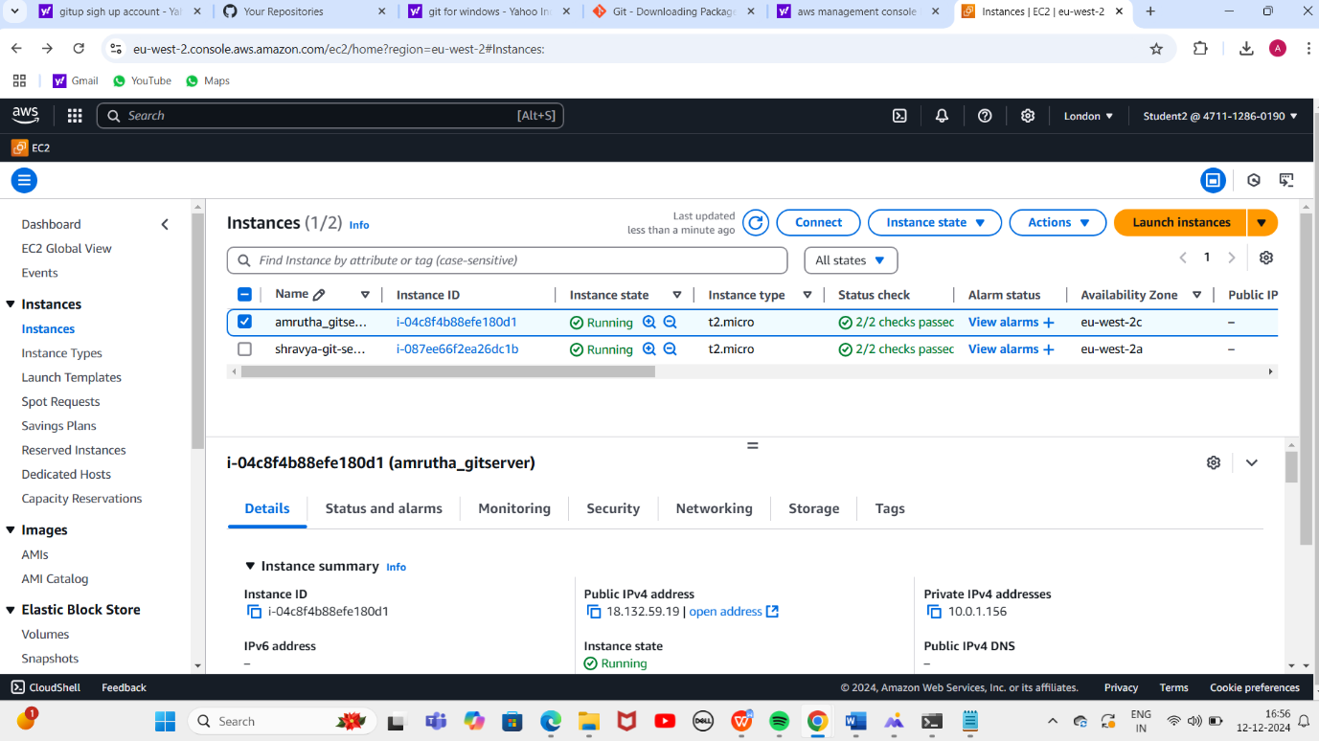

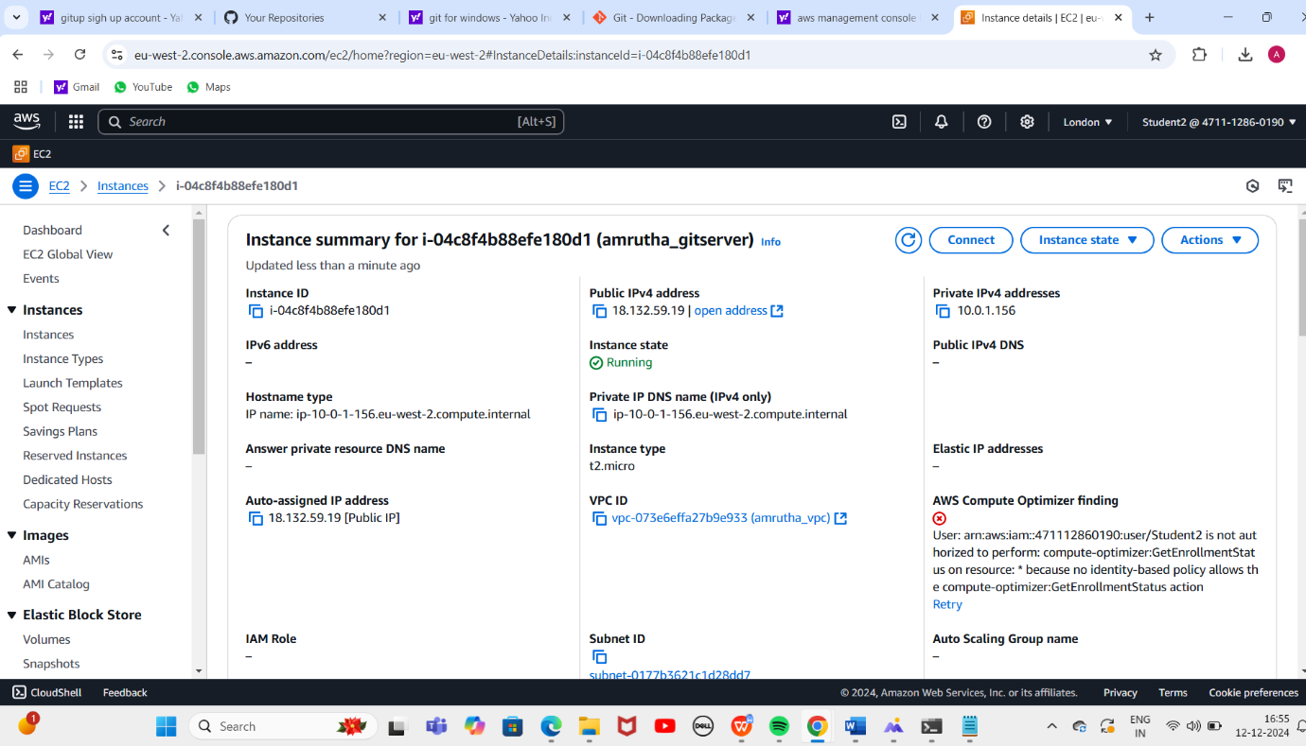

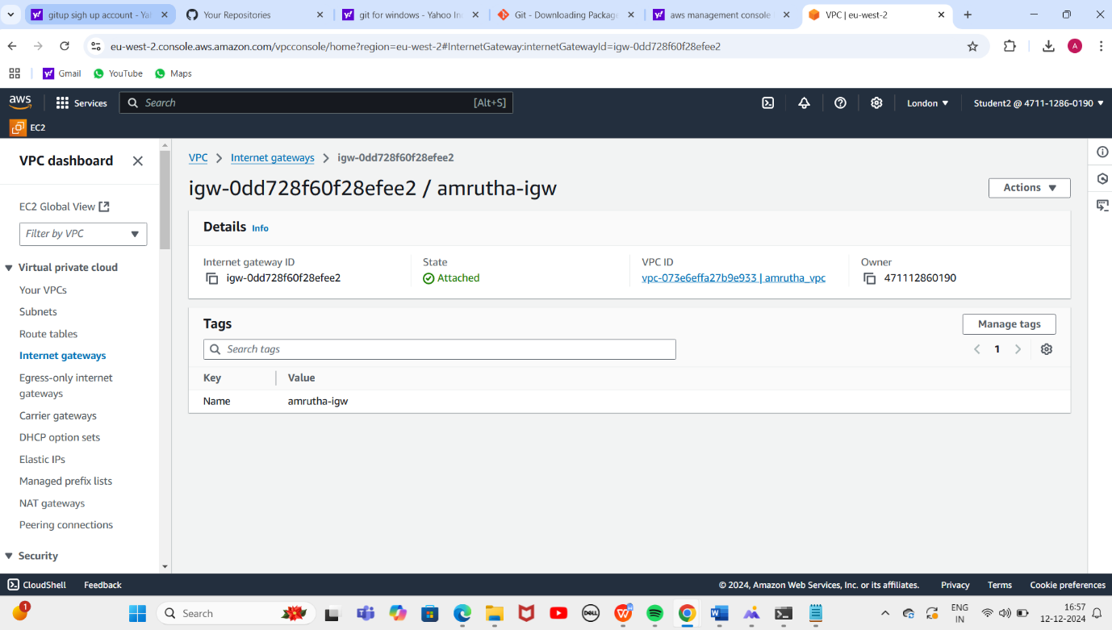

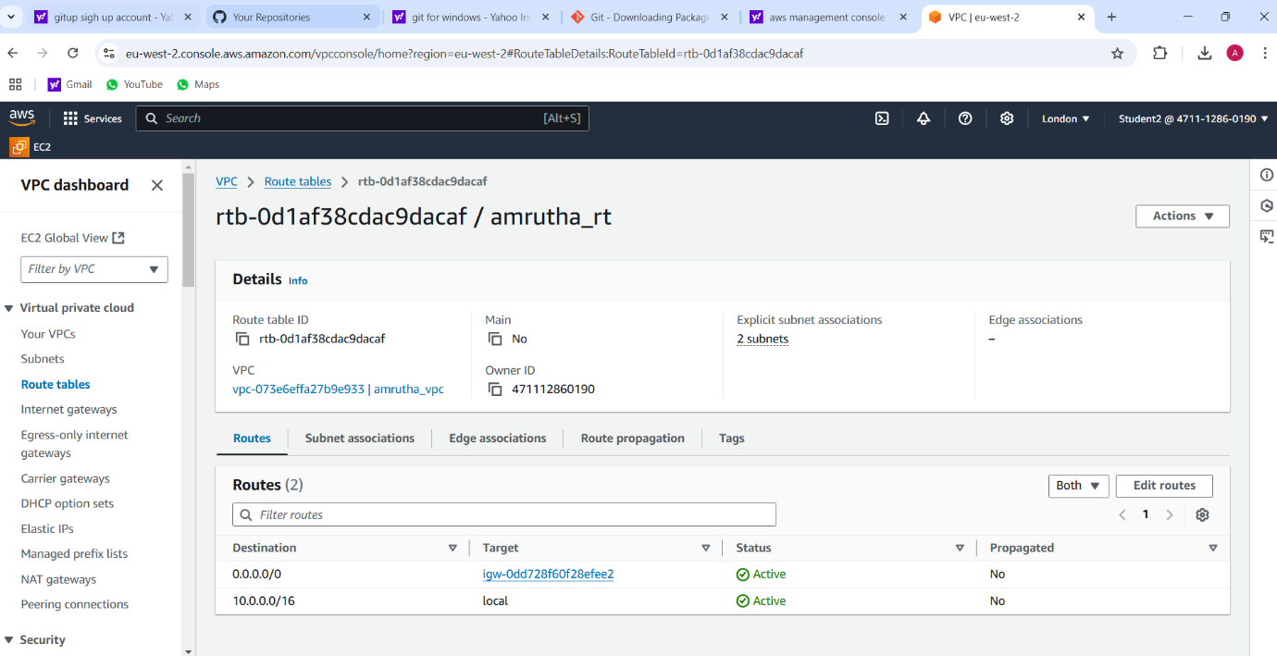

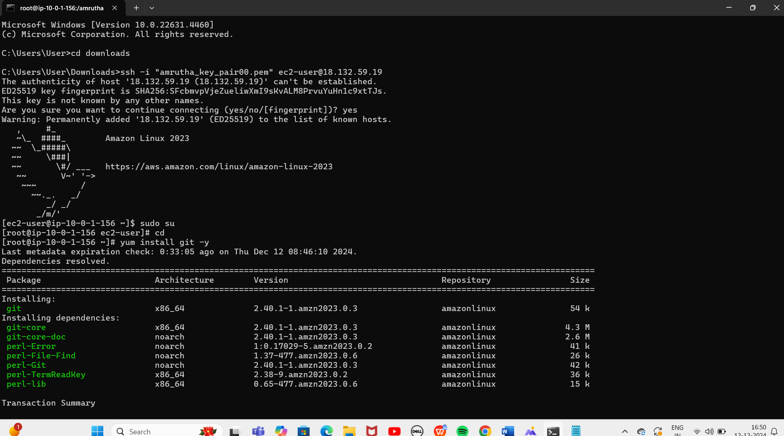

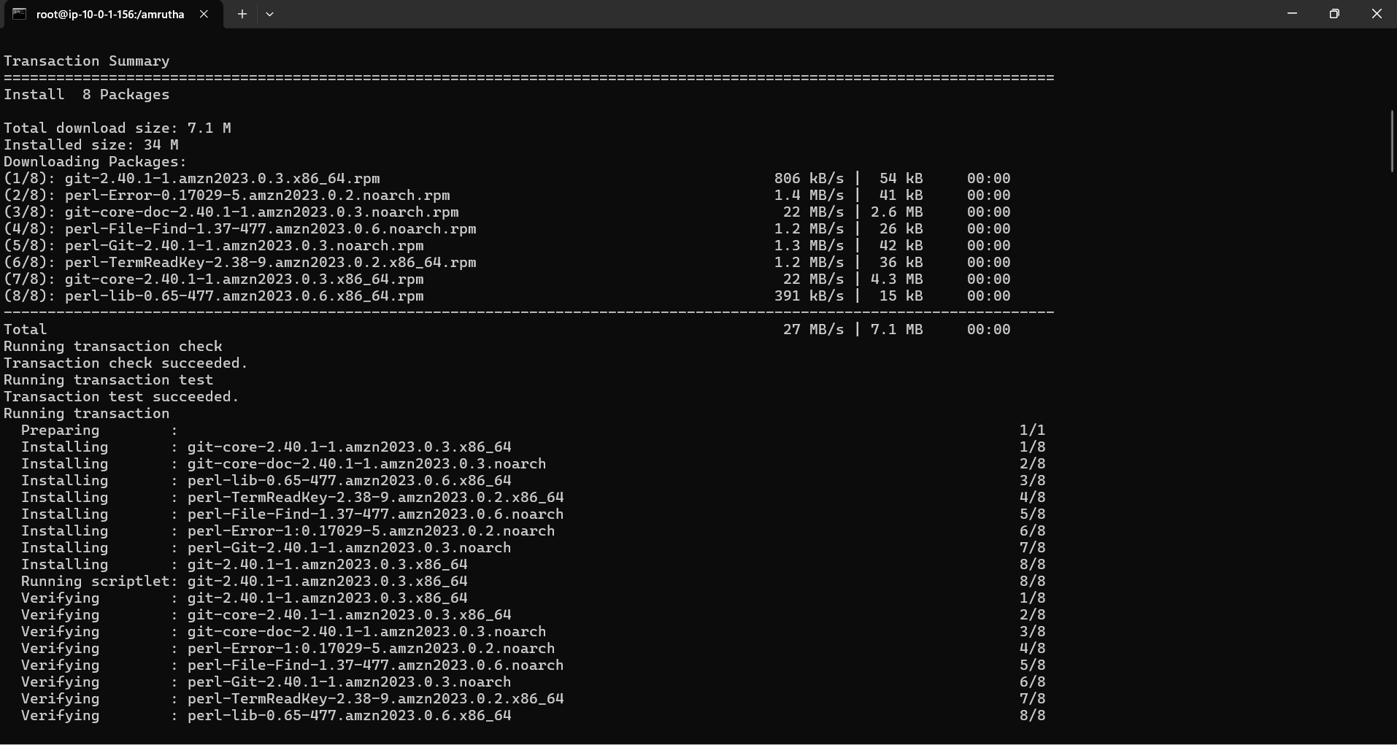

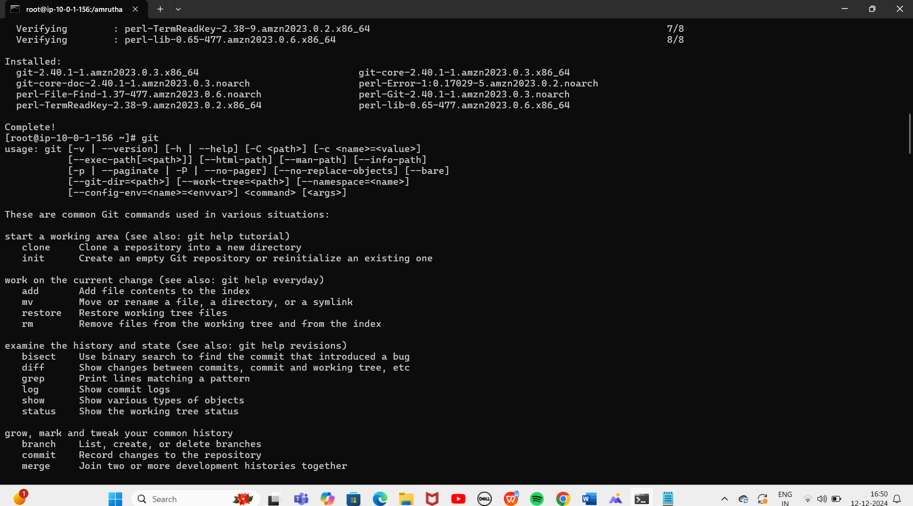

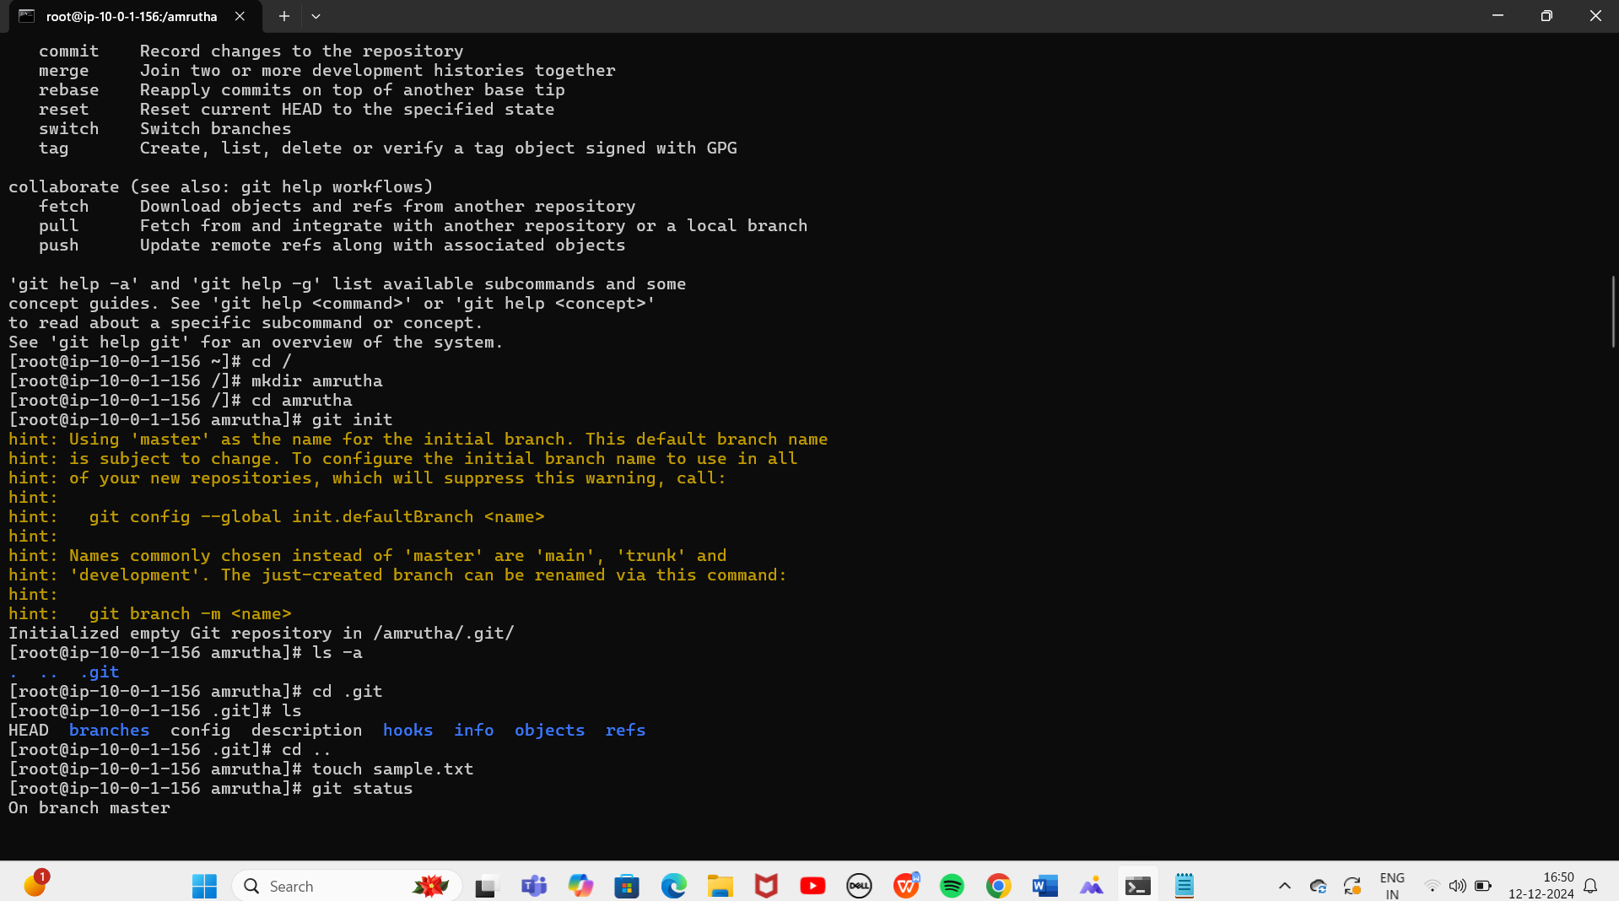

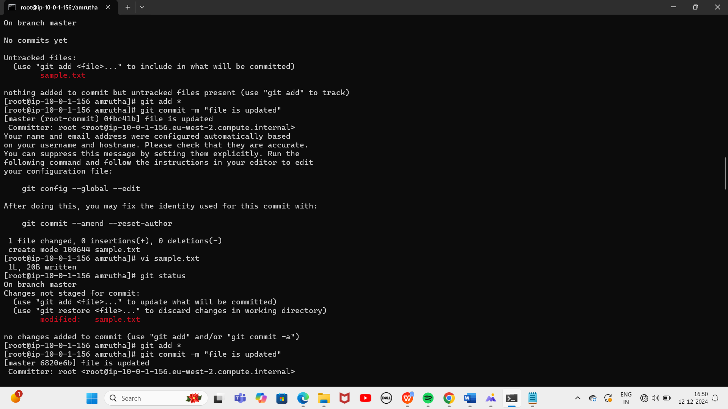

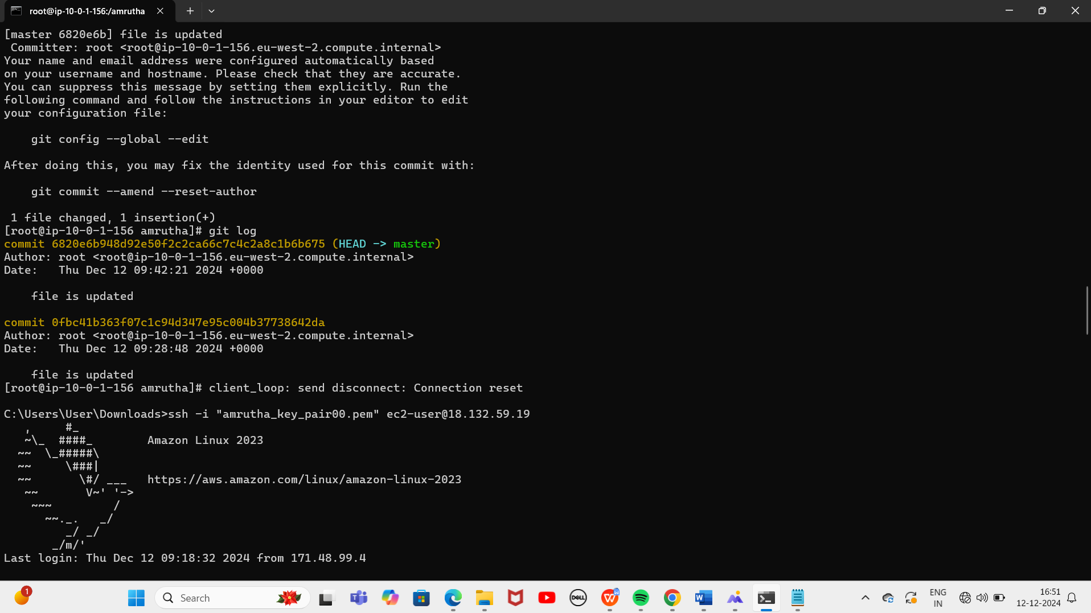

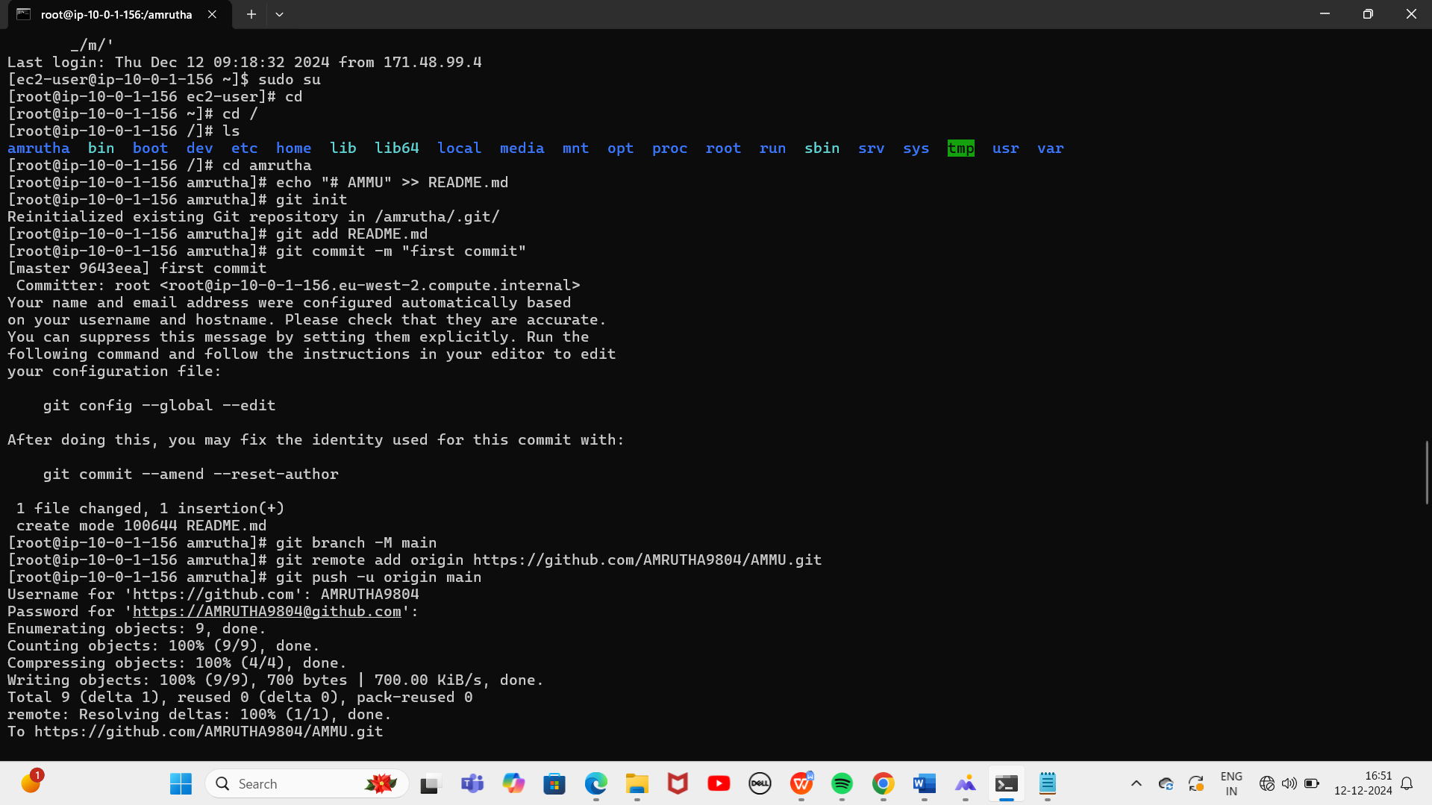

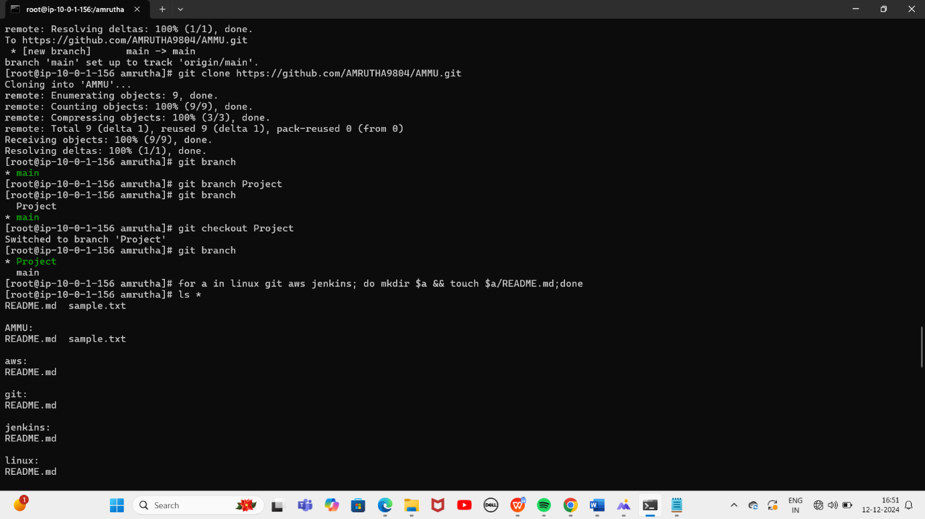

**Sample:how to create git branch in Github**

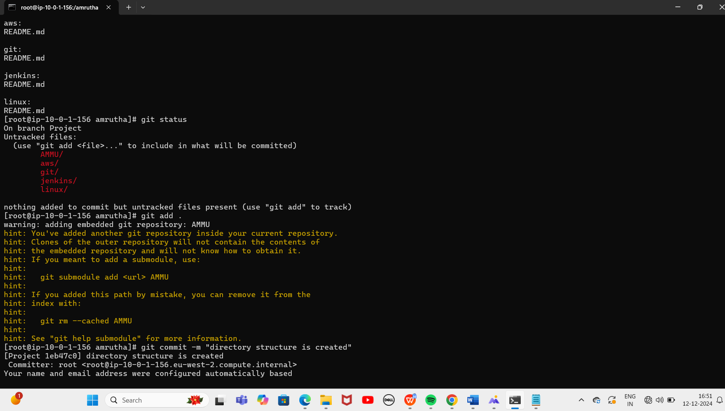

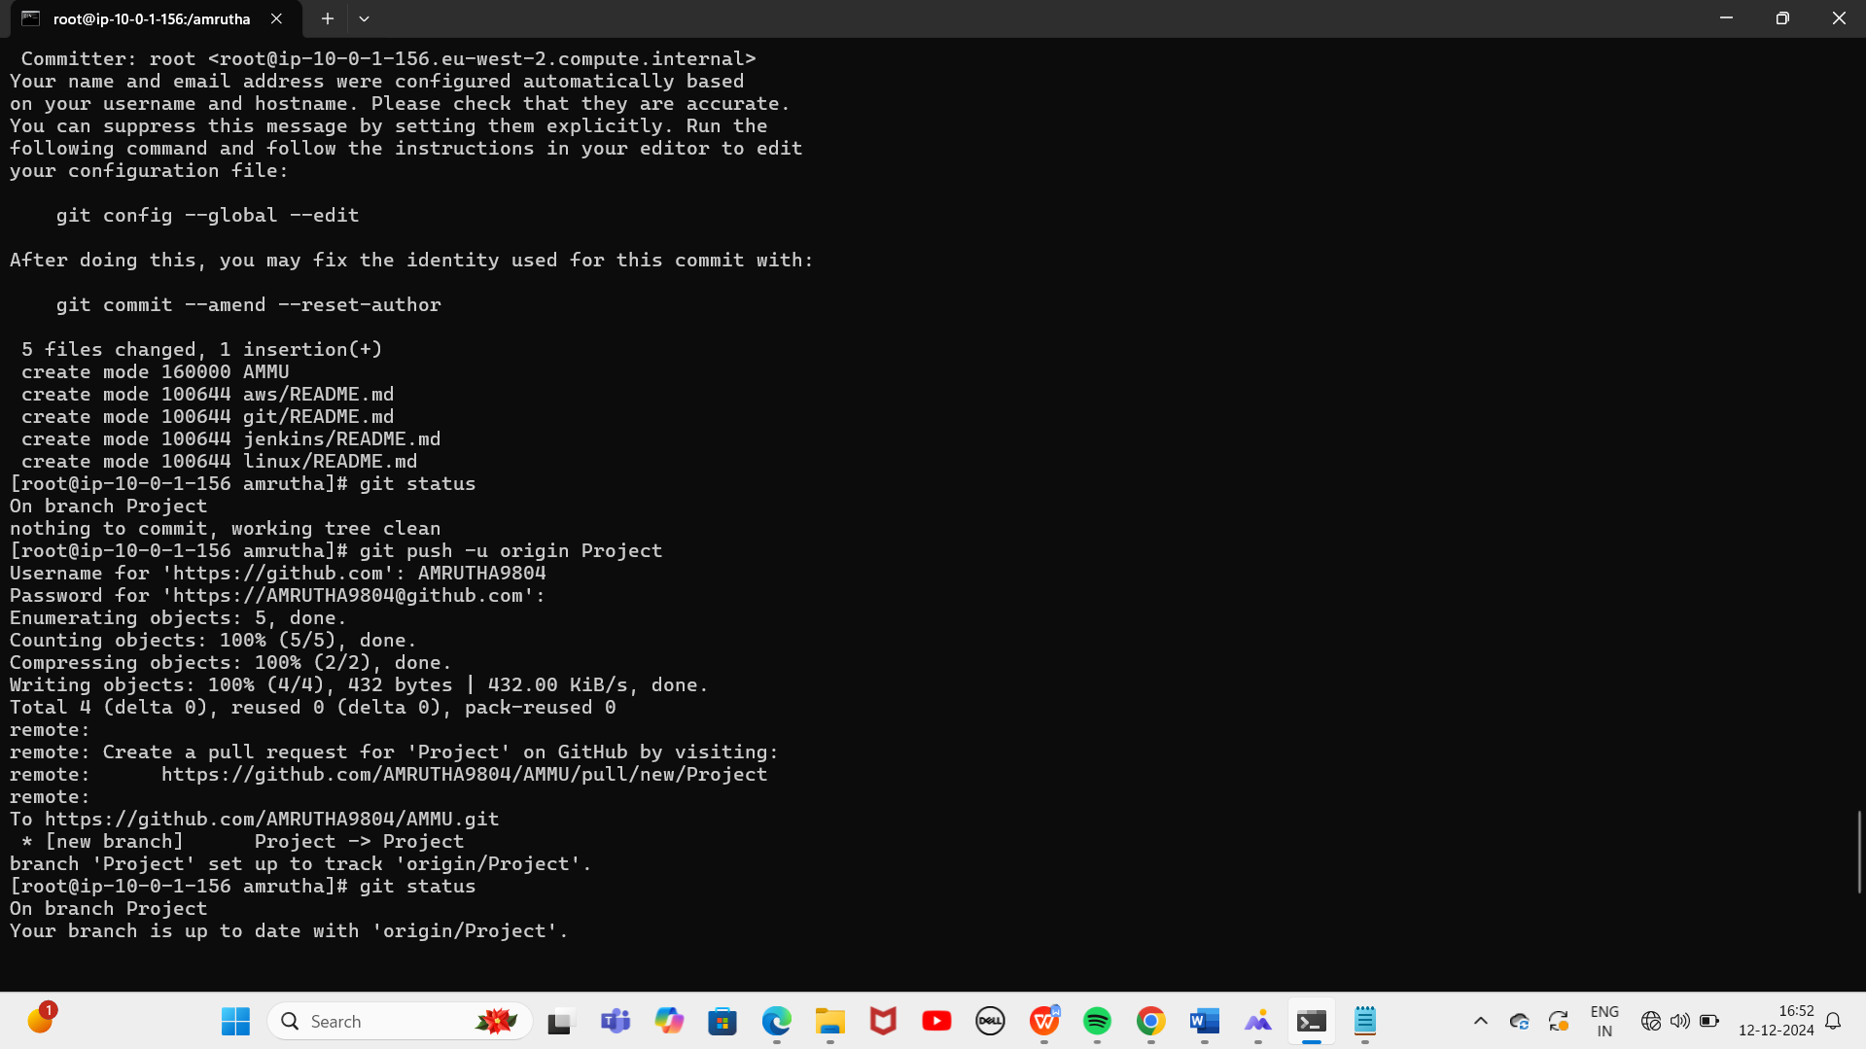

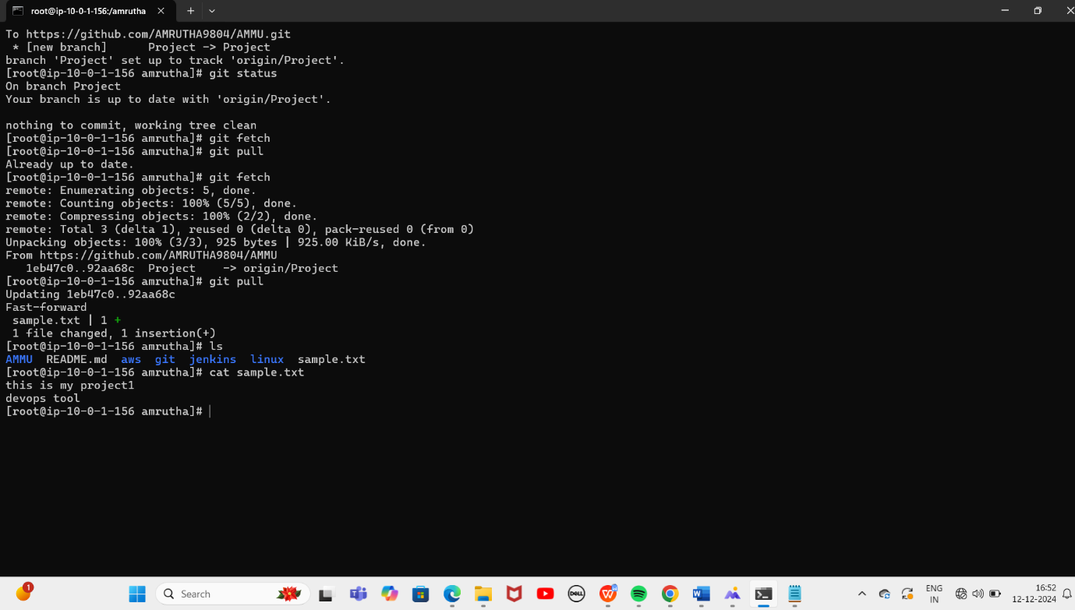

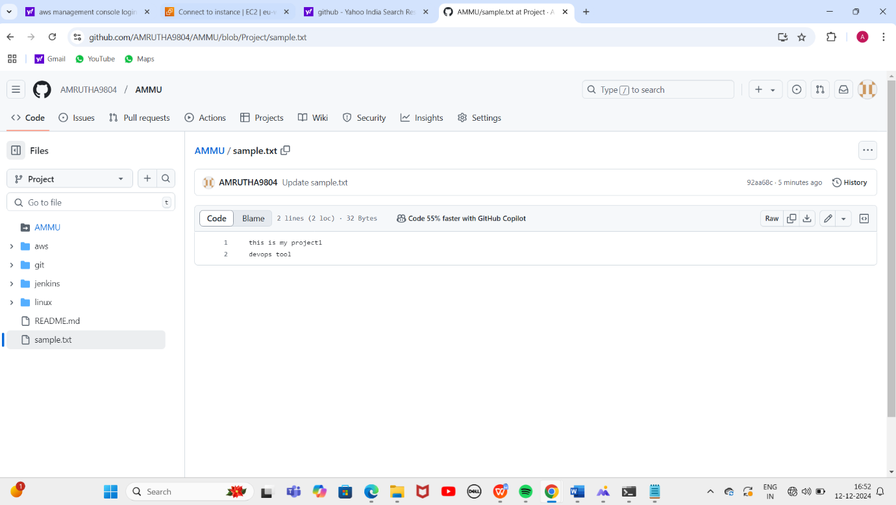

**7.PROJECT**

**HOW TO DOWNLOAD AND RUN PROJECT FROM GIT HUB**

Repositories:Simple-reactjs-app

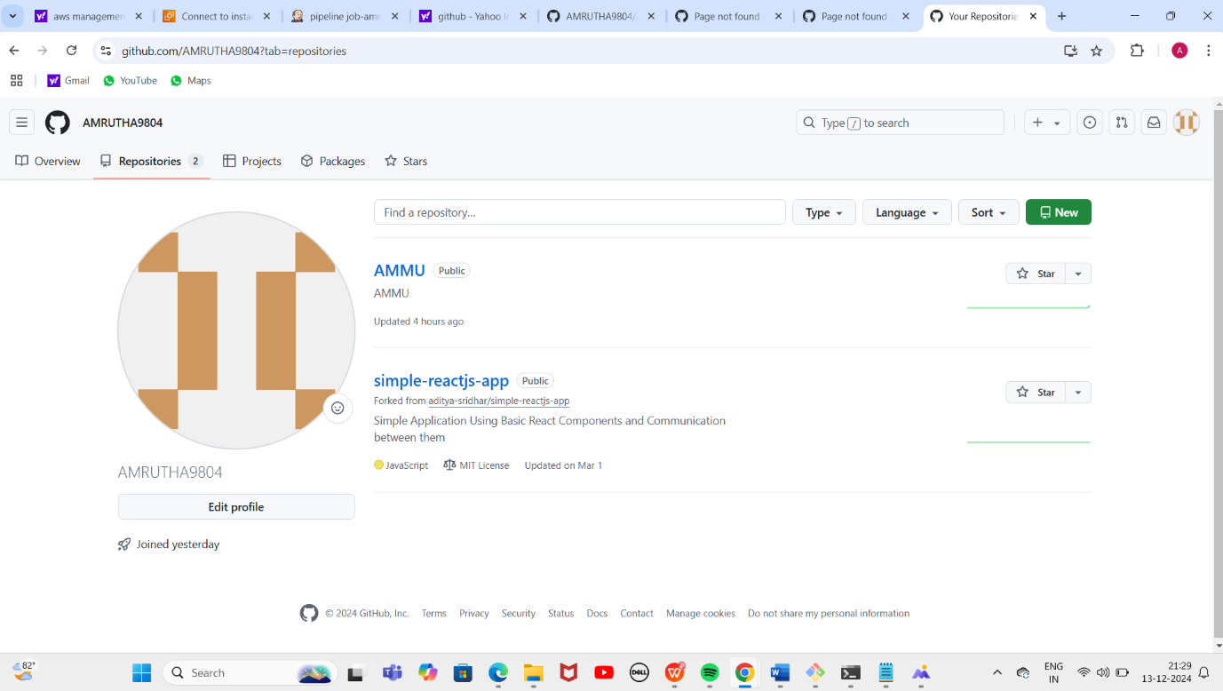

Clone url:-

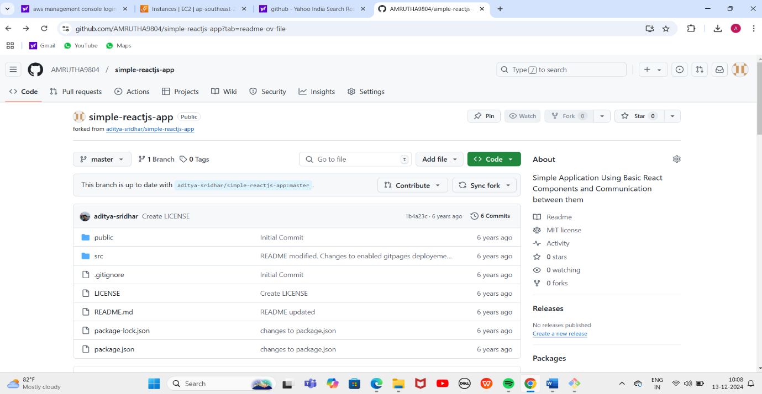

Cloned simple-reactjs-app:

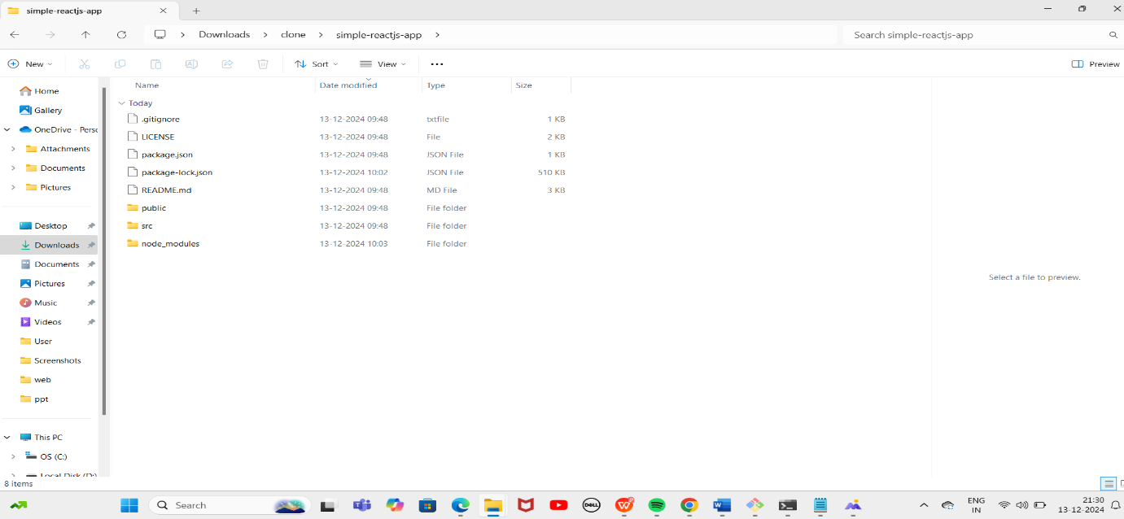

Command prompt:

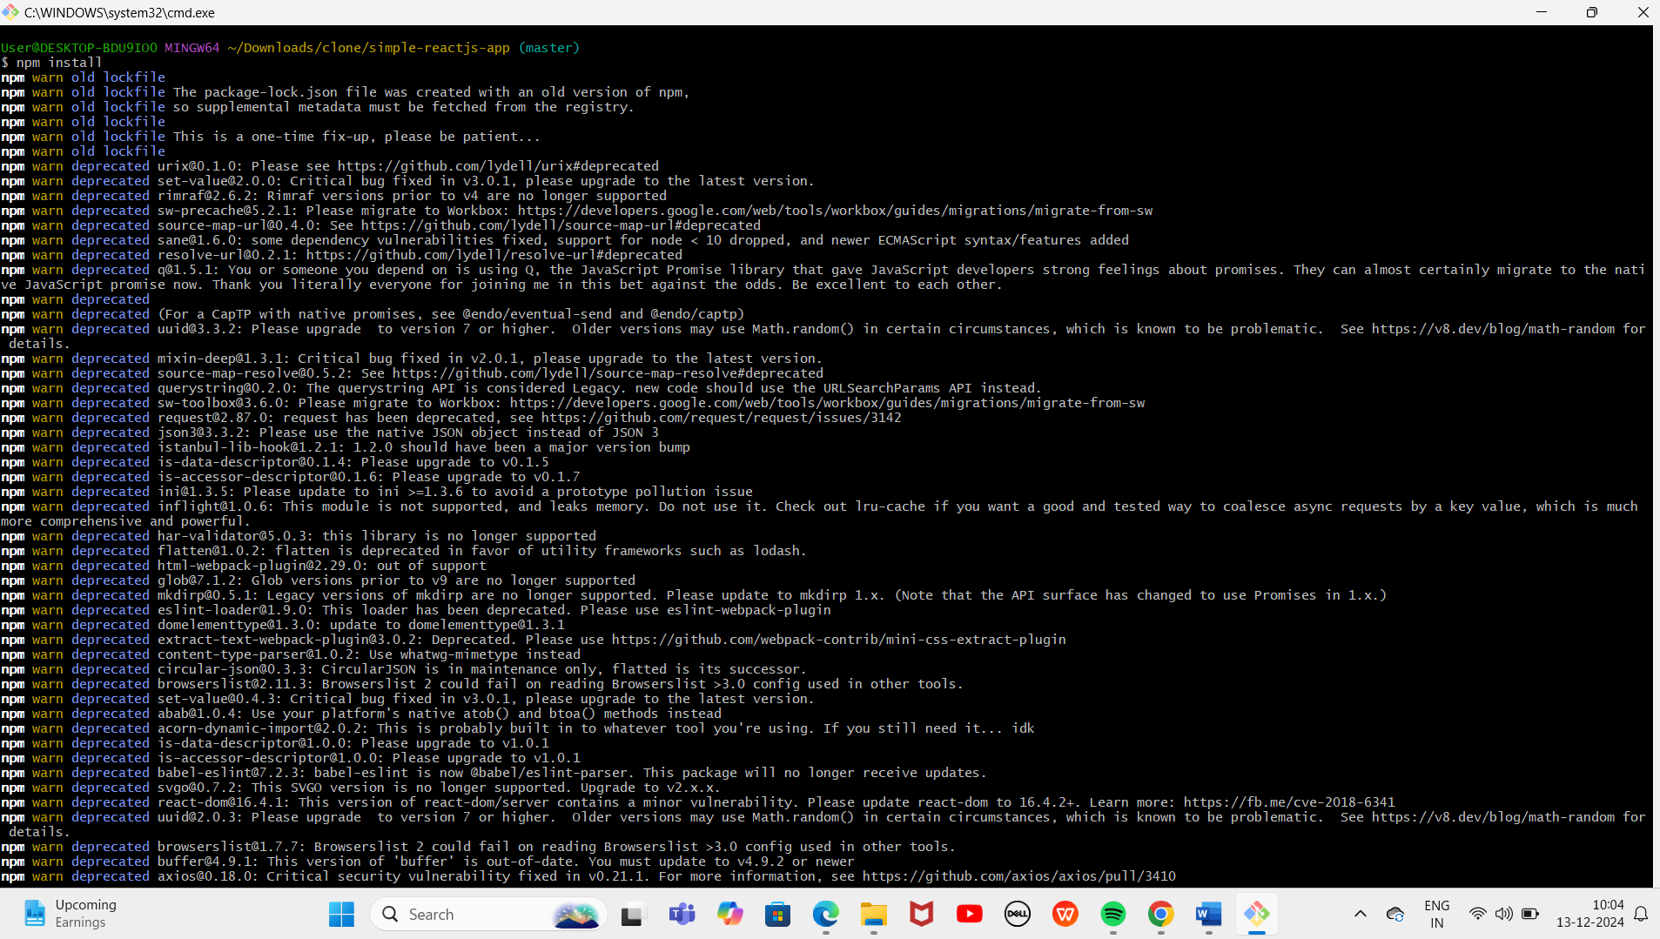

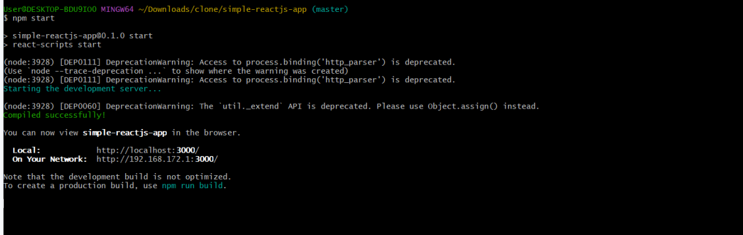

Final Result:

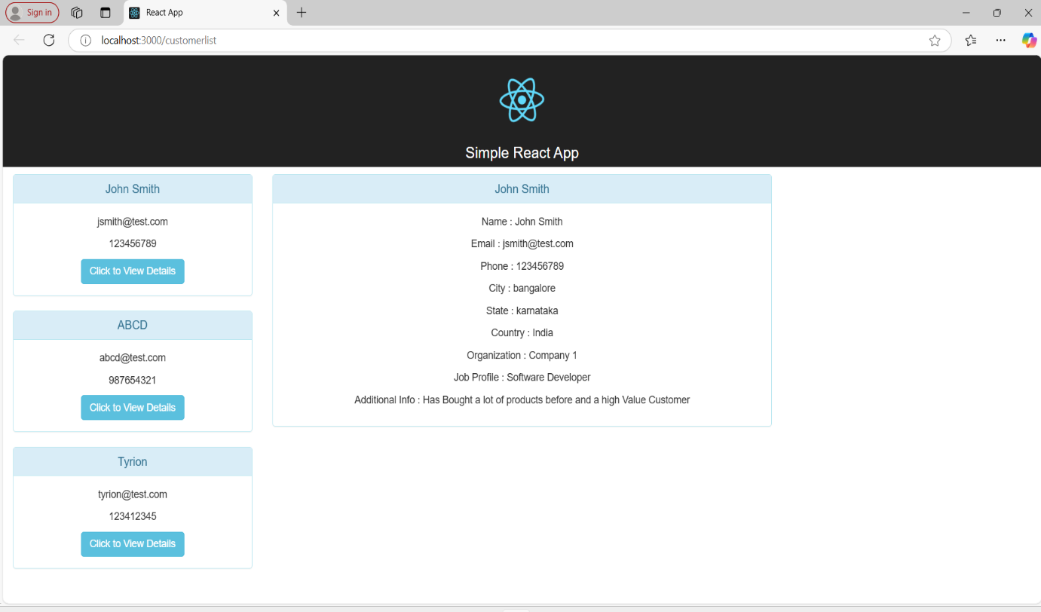

Sample example:-

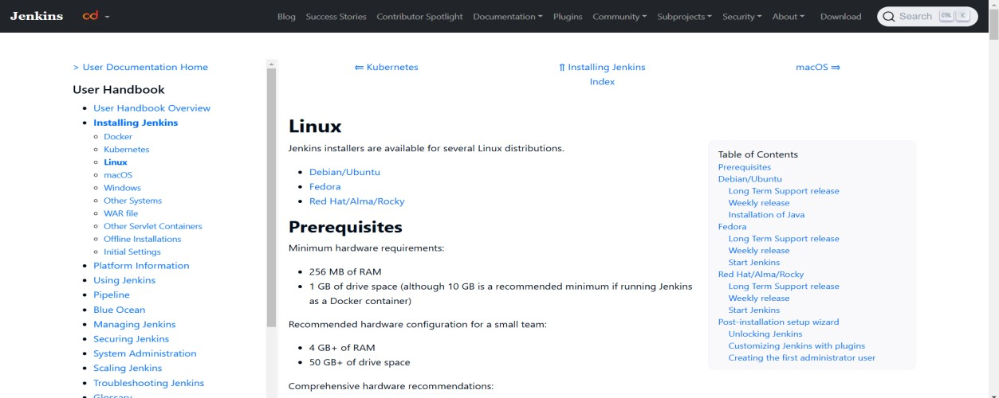

Installation of java

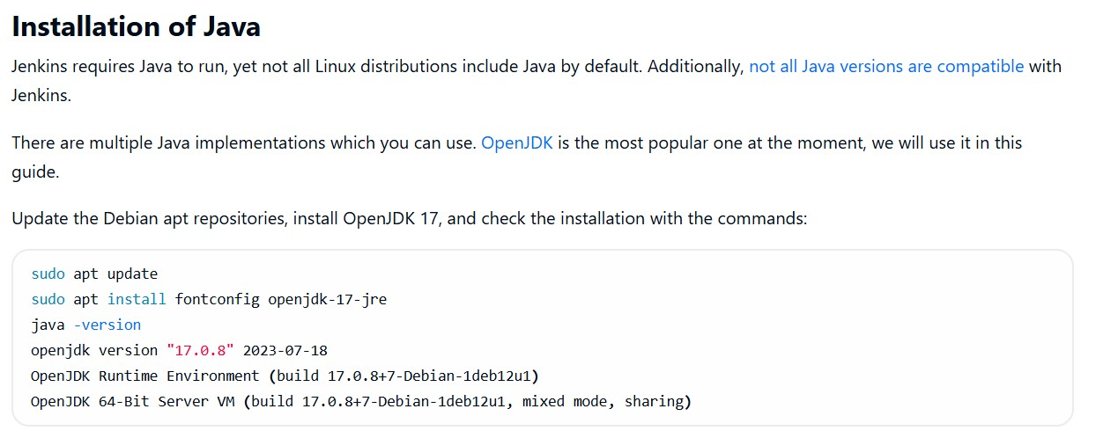

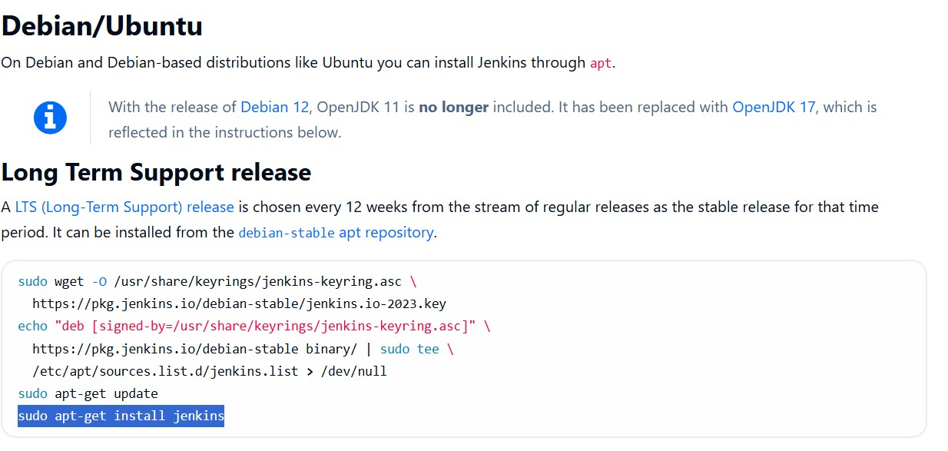

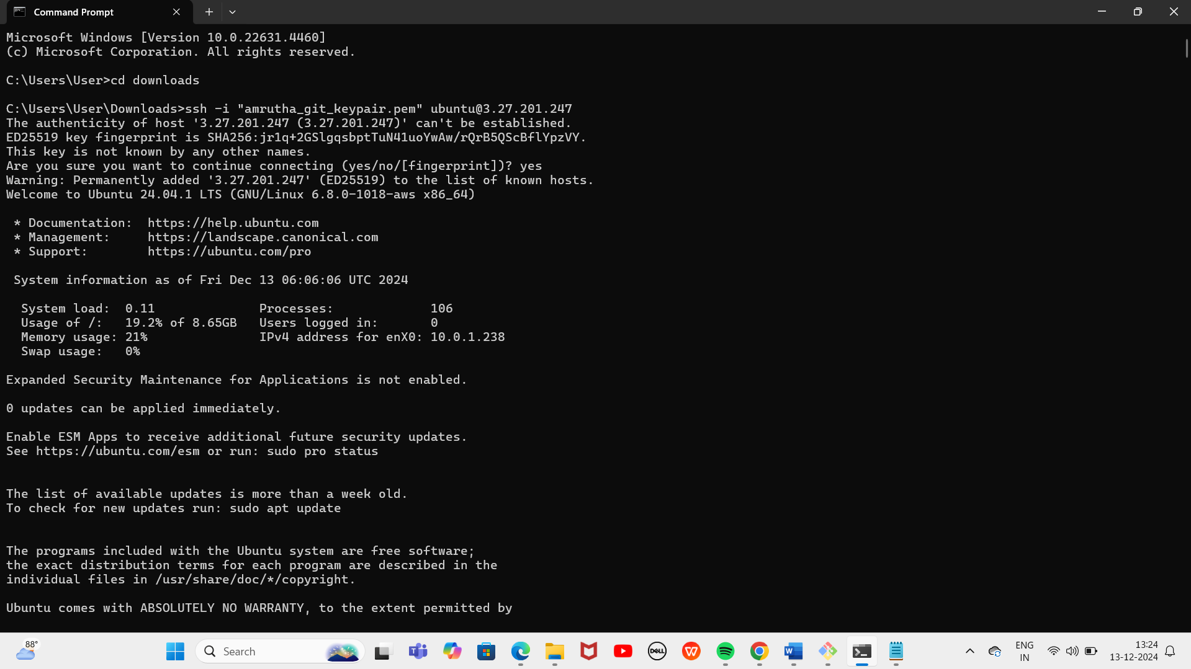

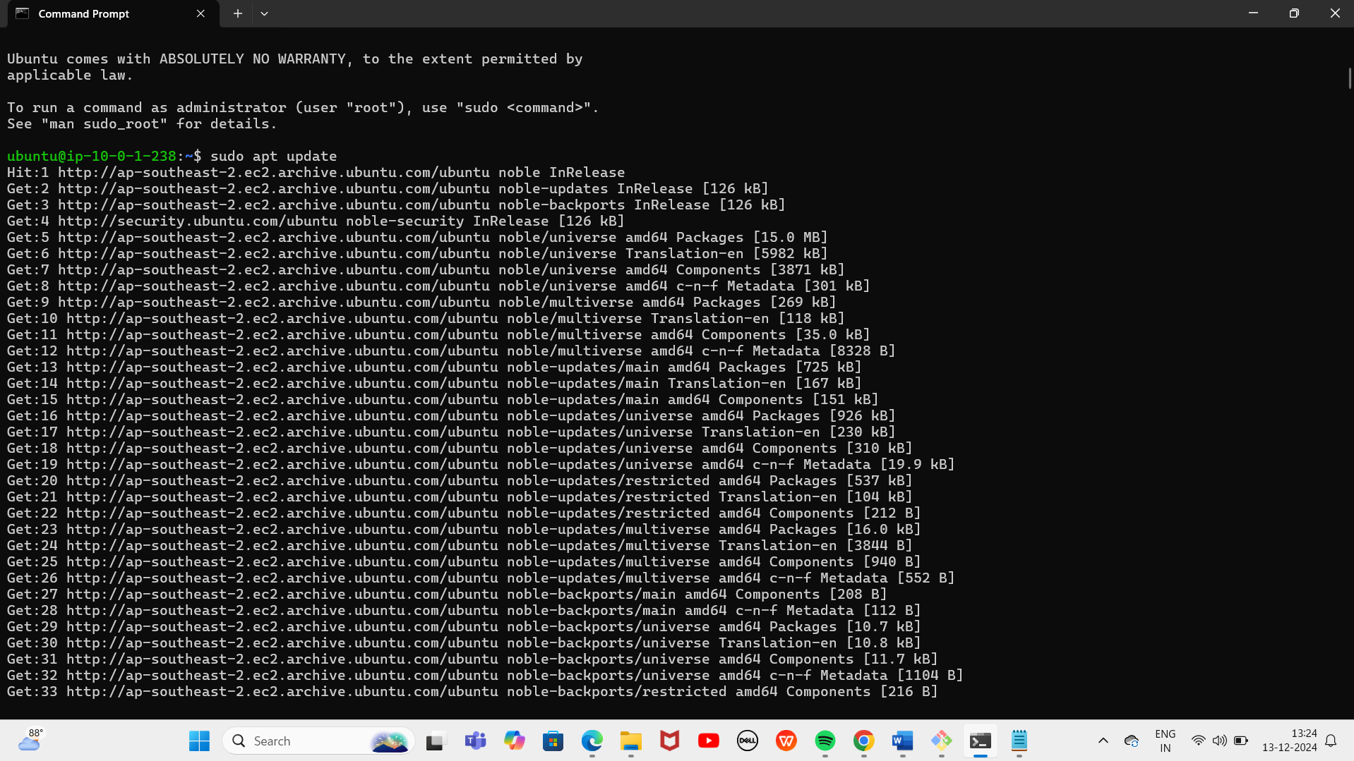

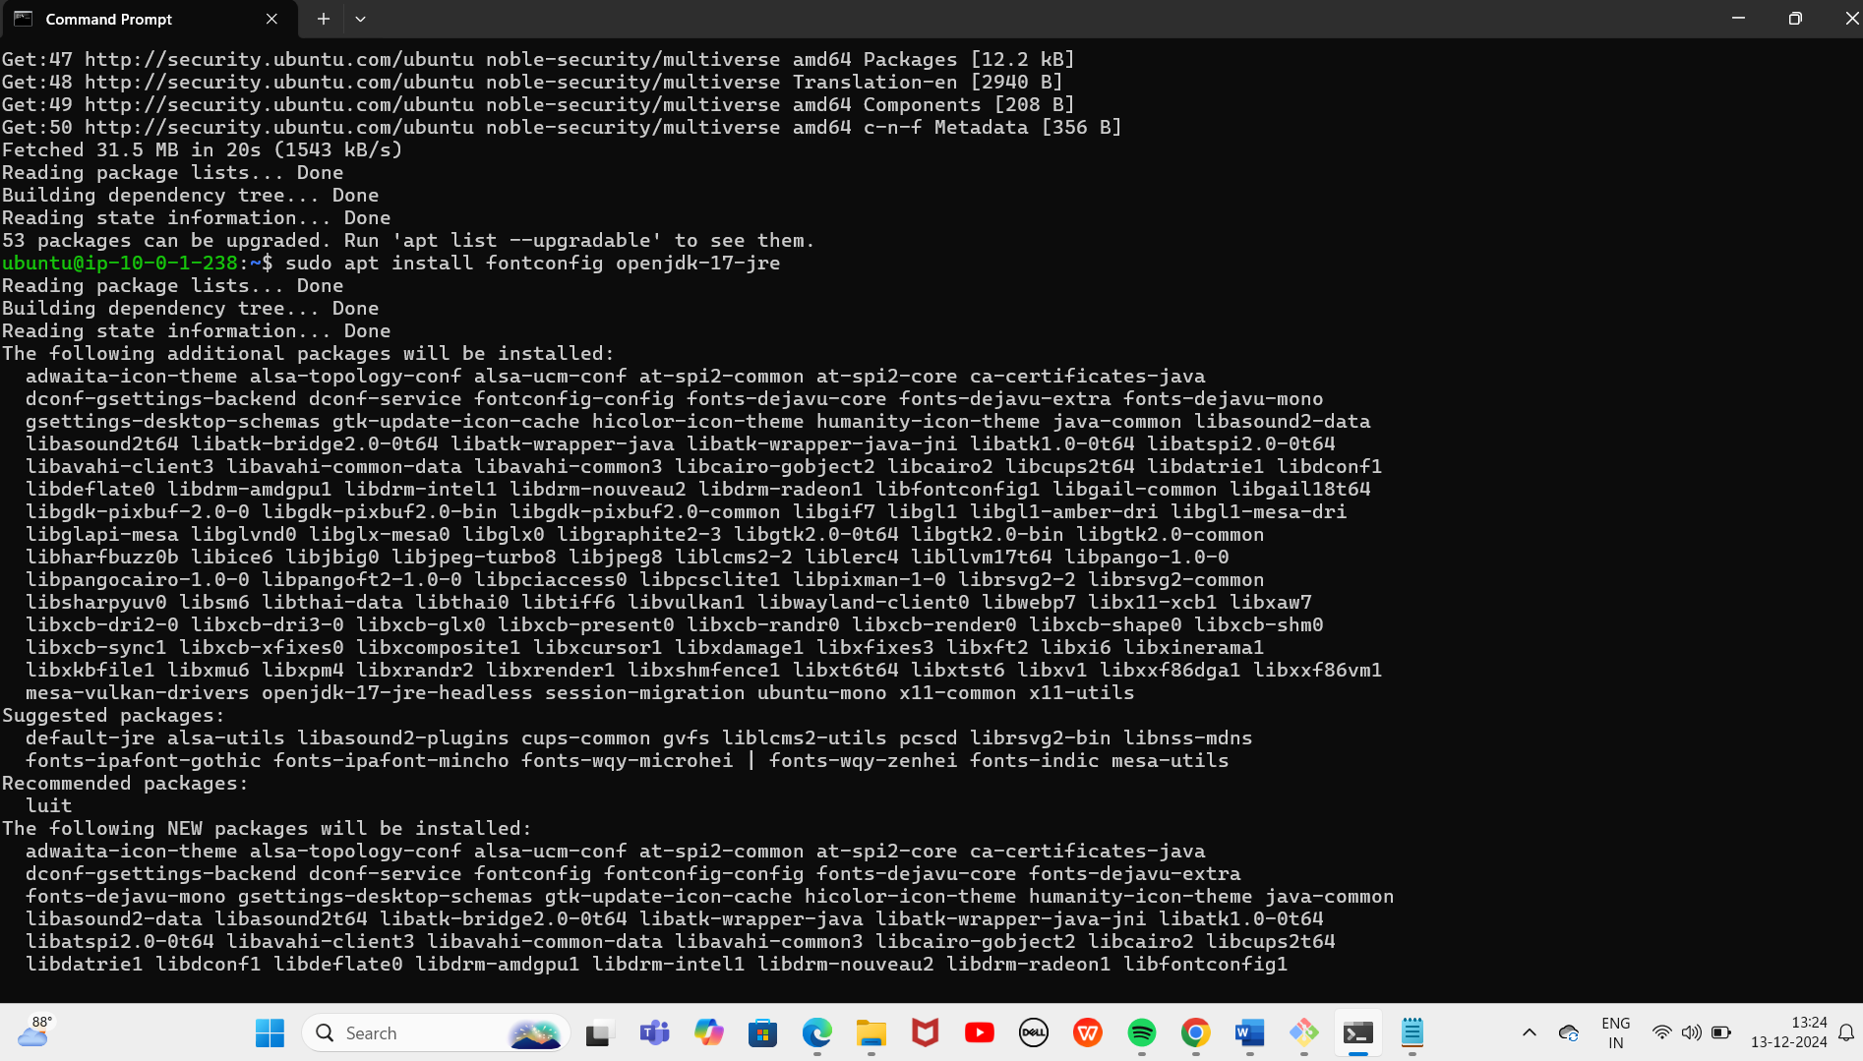

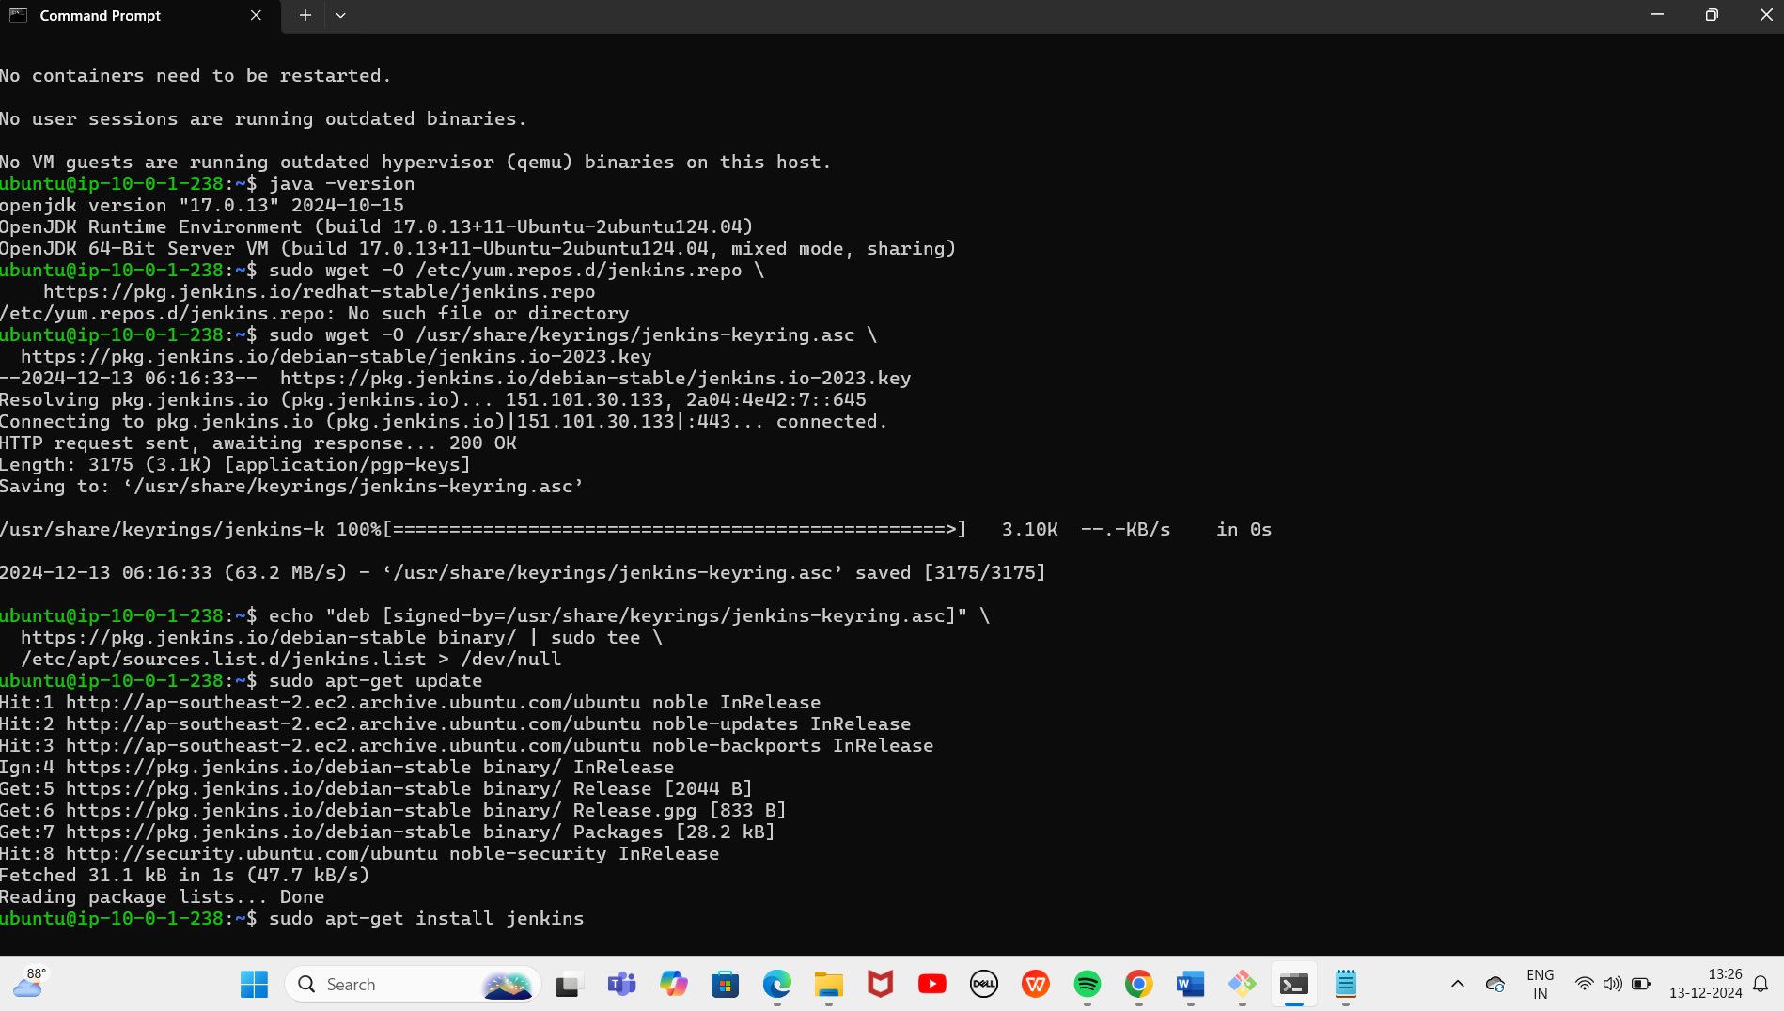

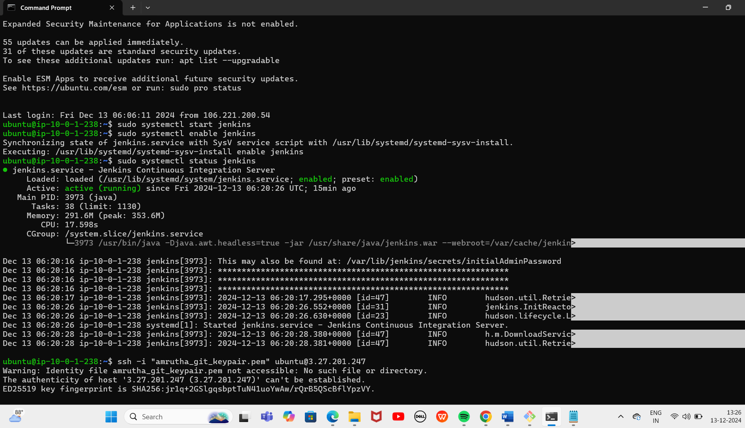

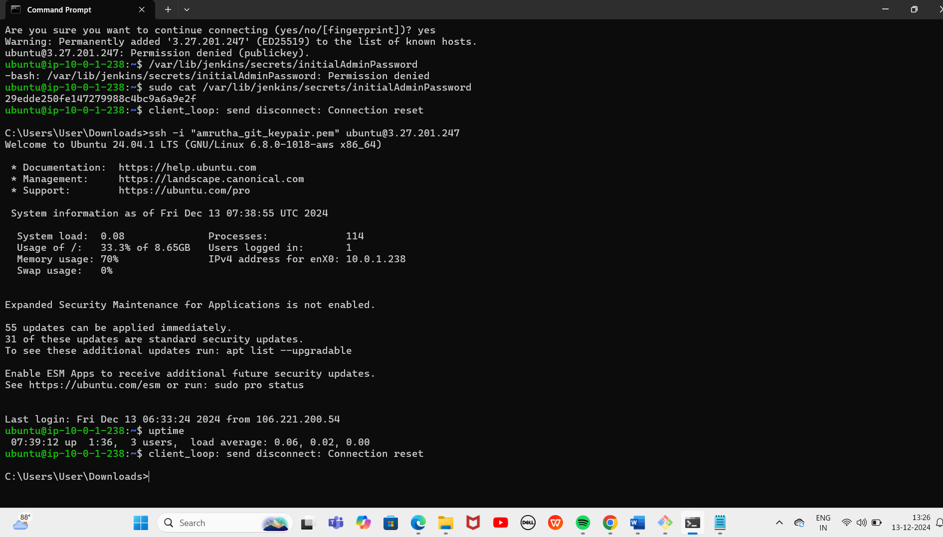

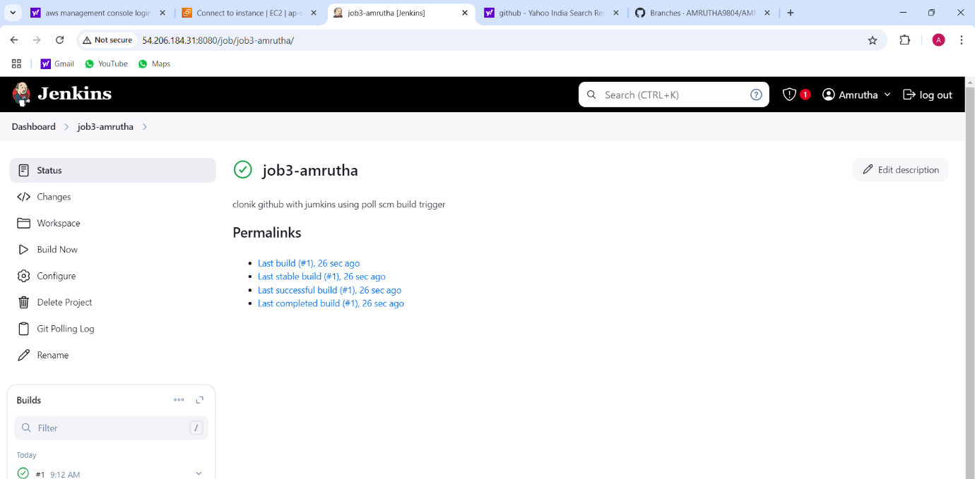

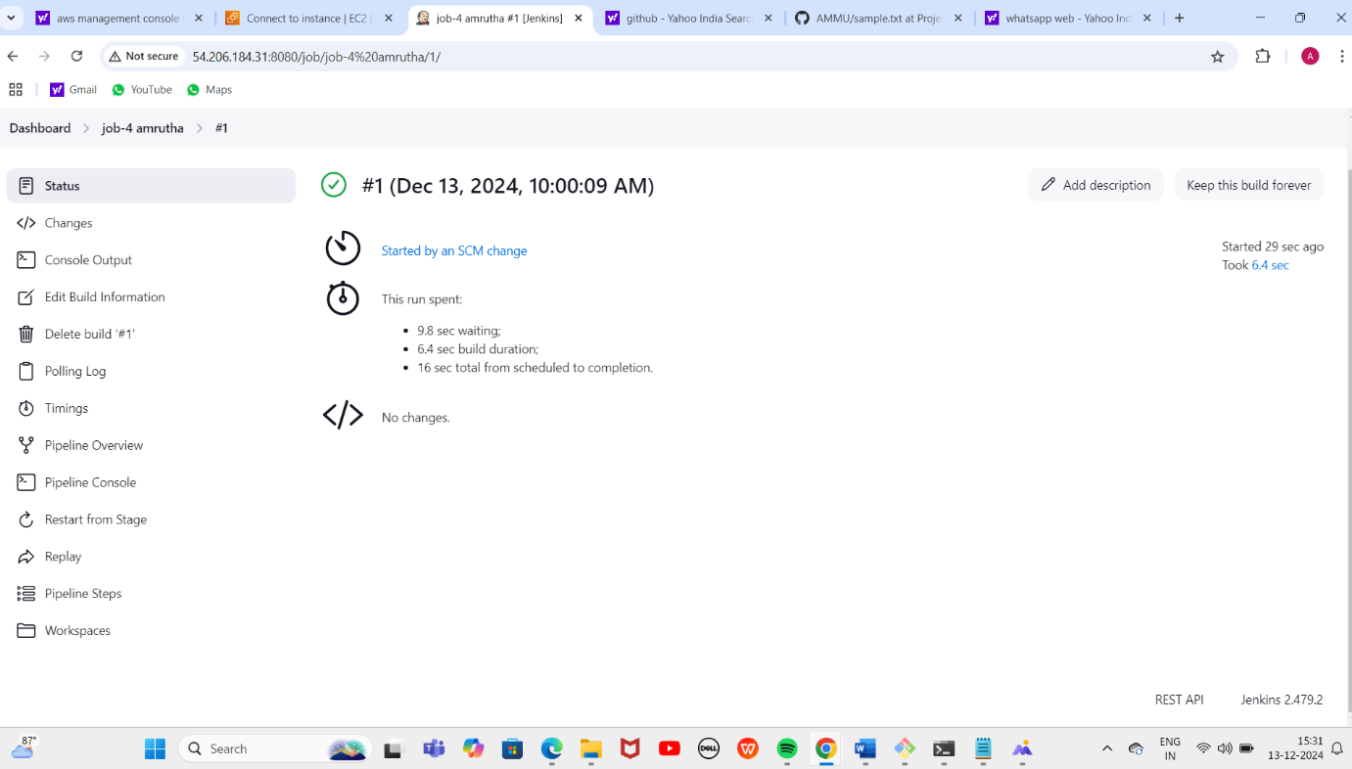

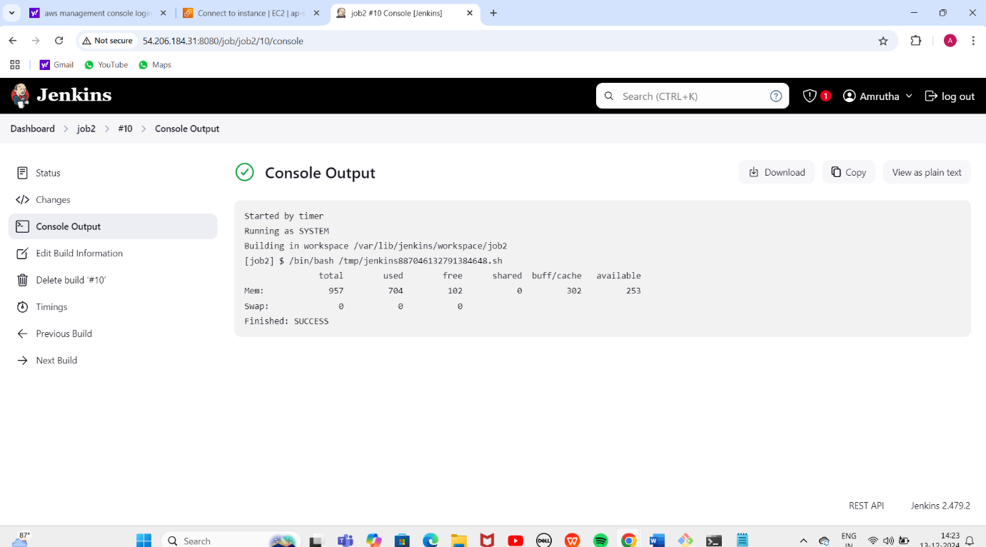

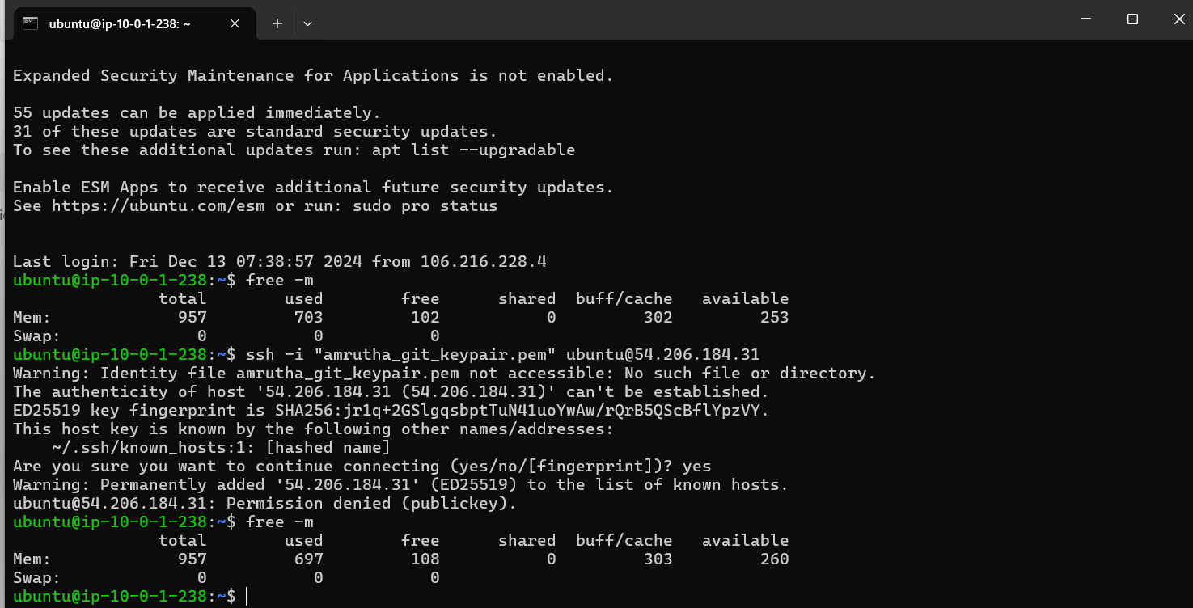

Project -8

How to clone GitHub witH jenkins usinG Poll scM build triGGer creatinG

the job-3-amrutha:

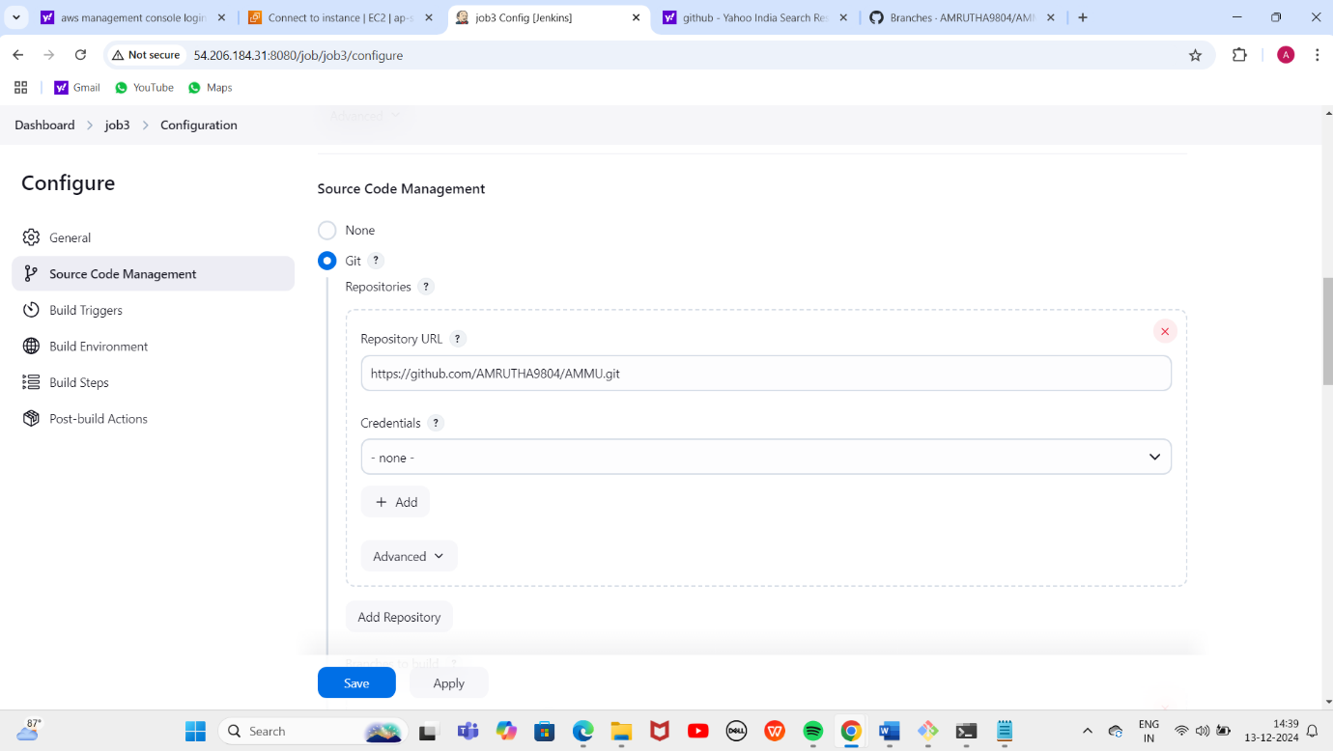

Selecting the Source code management:

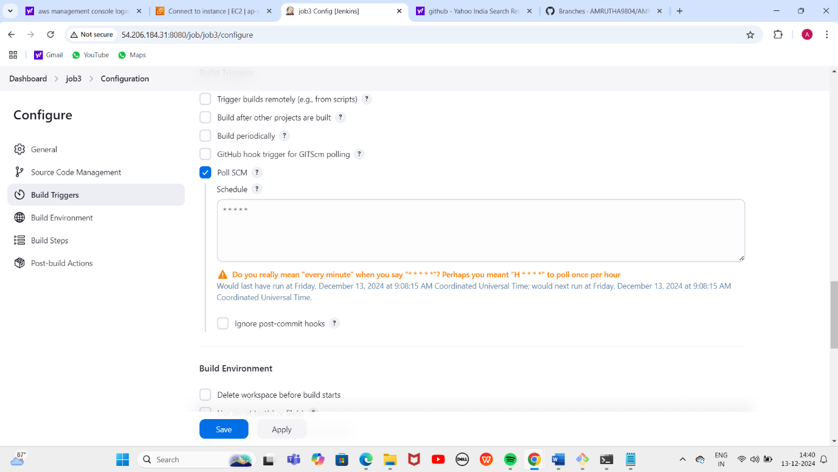

Copying the repository url:

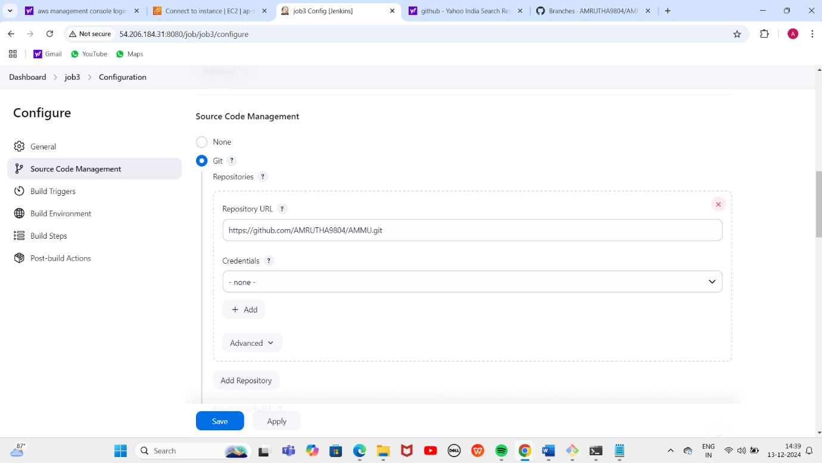

Build Trigger:

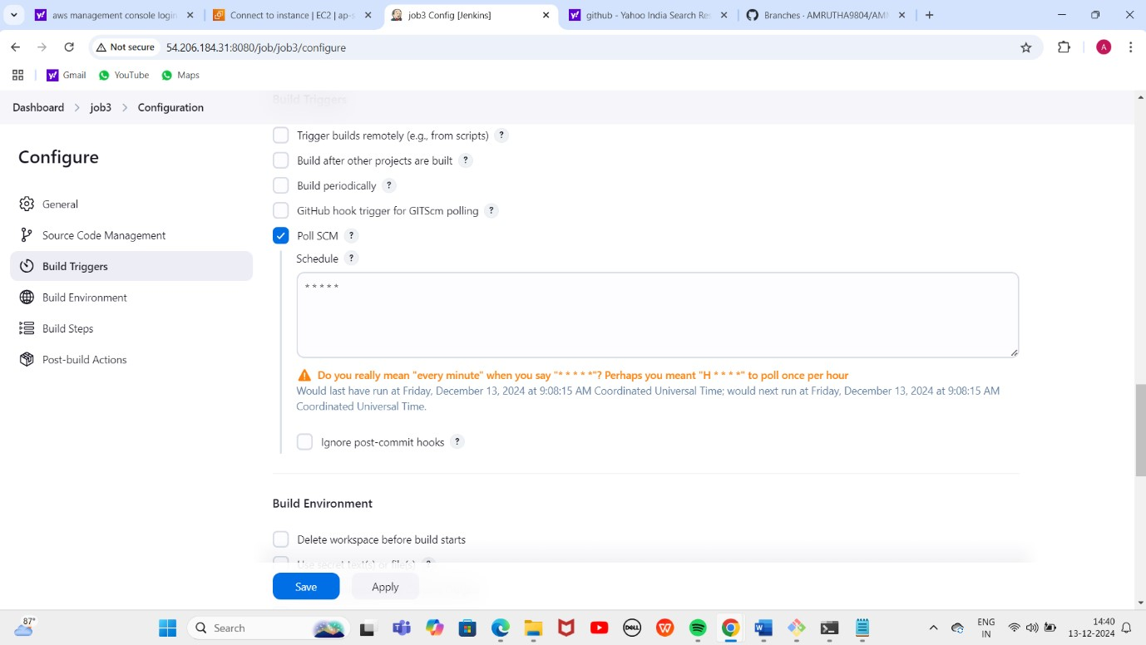

Editing the sample.txt file and committing the changes:

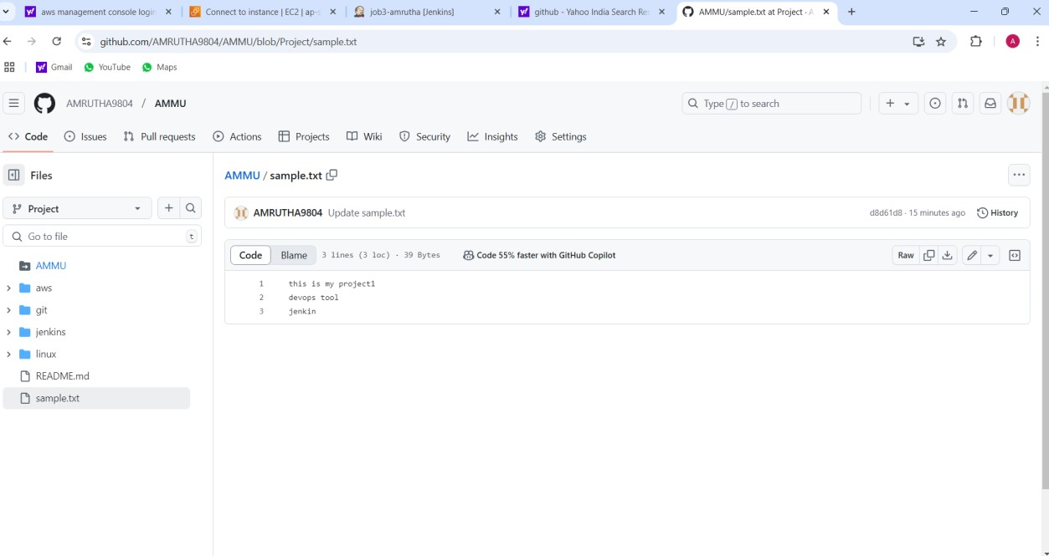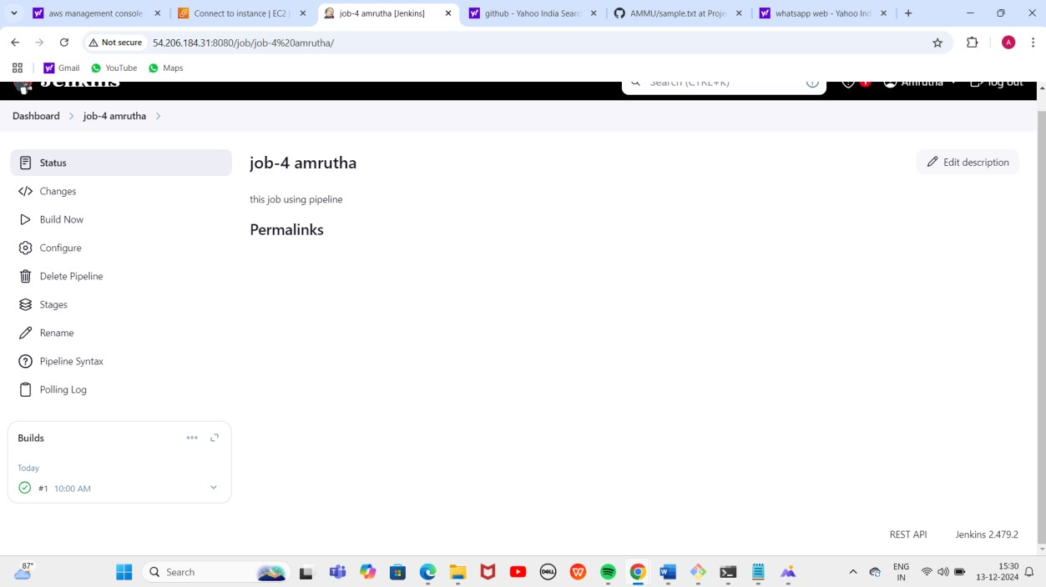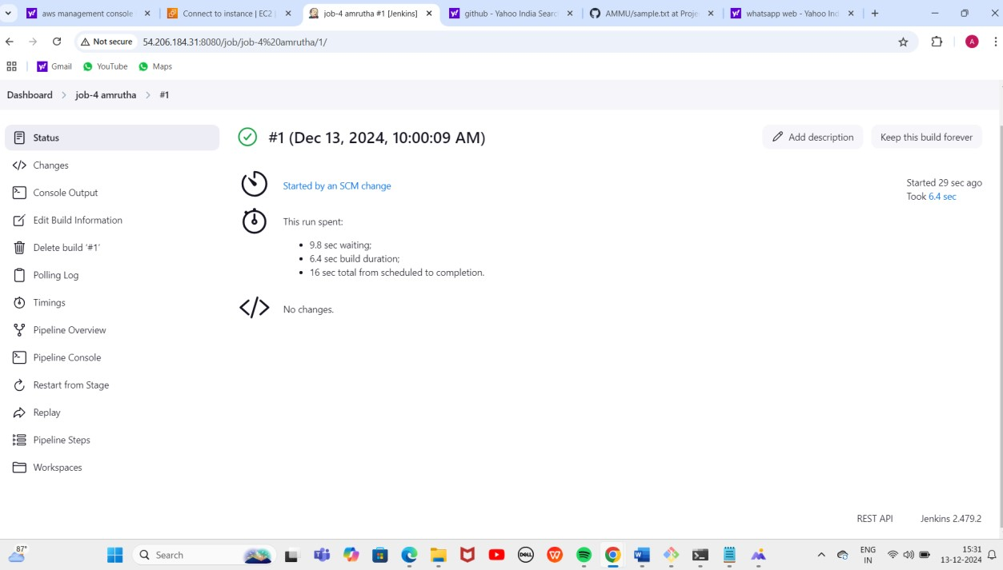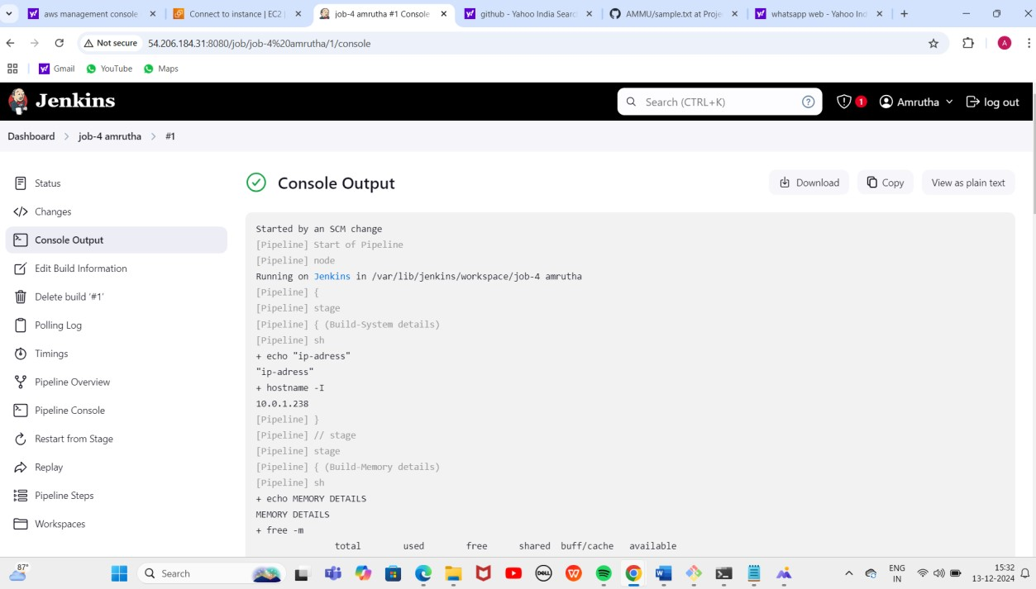

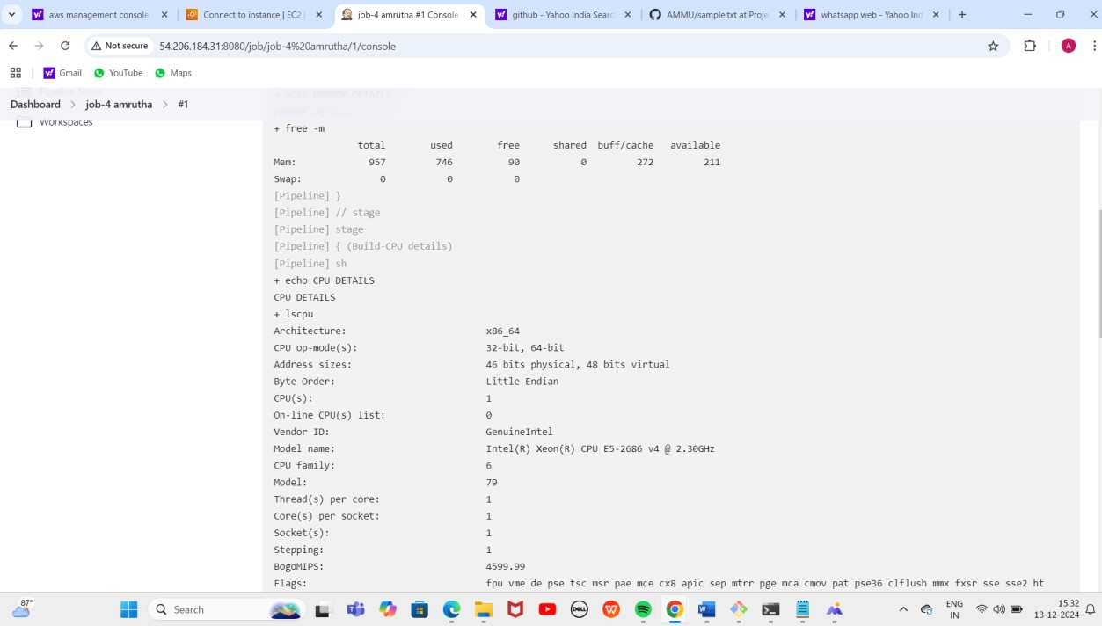

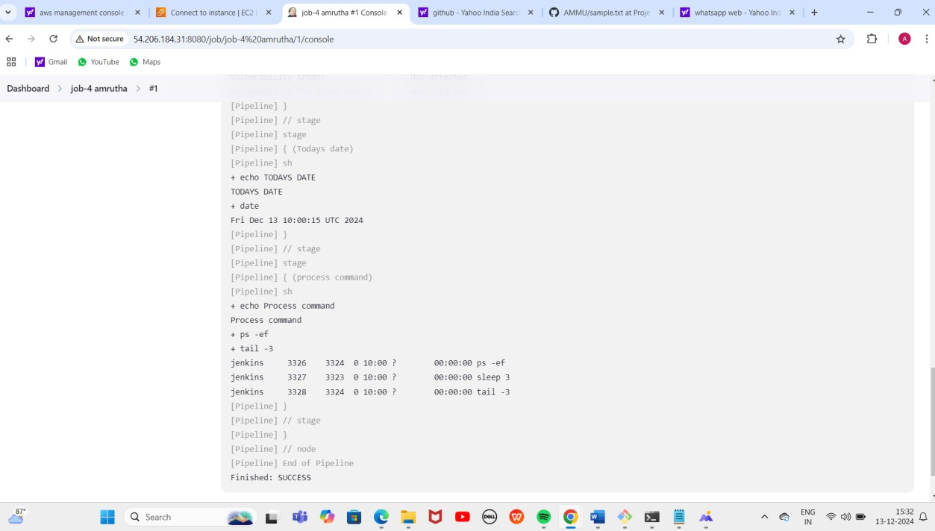

Project -9

How to automatically trigger the job in Jenkins using pipelines integrating with GitHub Dashboard:

